This is a microscopic image of ____________________ and ___________________. Label both structures.

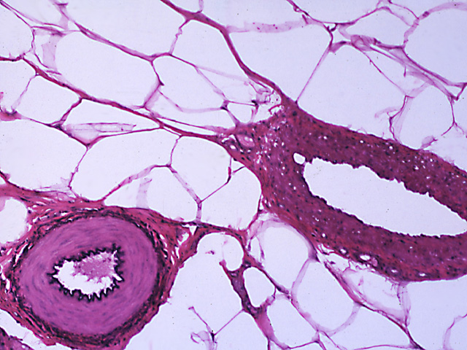

This is a microscopic image of ____________________________. Label the inner endothelium (tunica intima), tunica media and tunica externa.

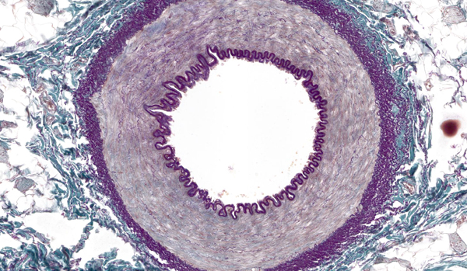

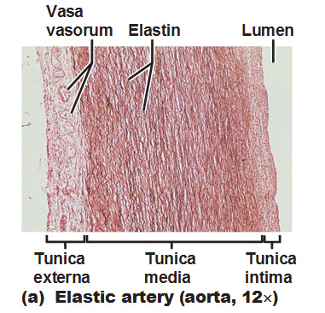

**Vasa vasorum: small blood vessels that supply the walls of the arteries and veins.

Microscopic image of artery and vein

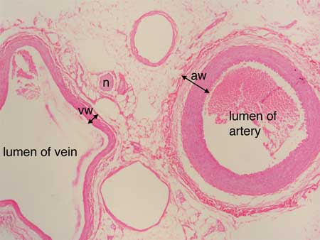

Microscope image of a ______________________containing ________________________.

Label these two structures.

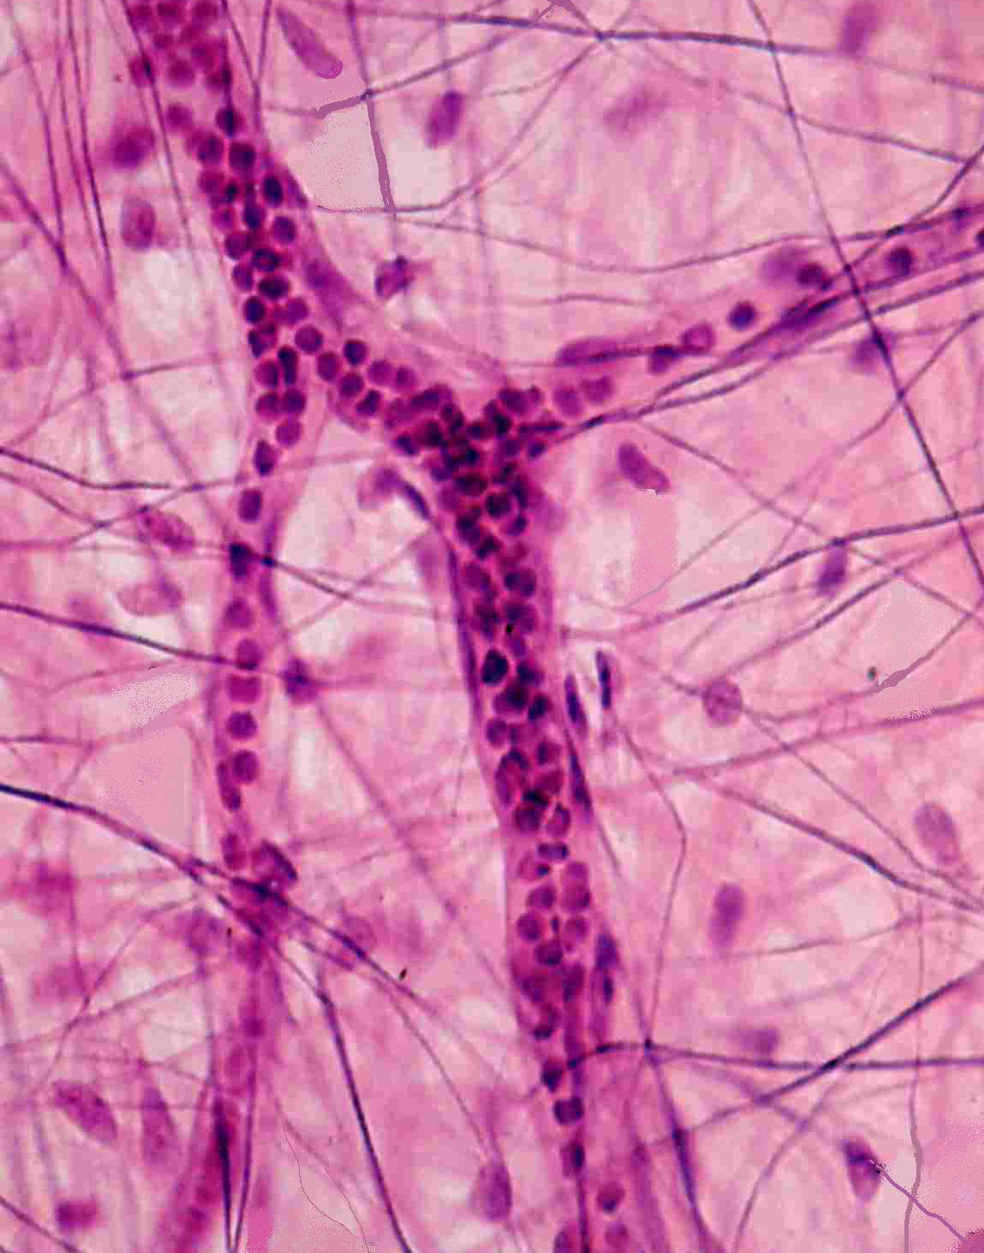

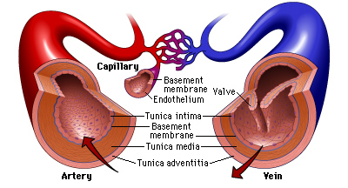

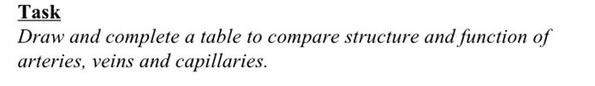

(a) The diagram below shows some mammalian blood vessels in cross section.



Vessel **X** is an artery. Its magnification is given on the diagram.

Calculate the actual width of the vessel in mm between points **E** and **F**. Show your working and express your answer **to the nearest whole number**.

Answer = ………………………………… mm

(b) Draw a plan diagram of the quarter section of the artery below. Label the tunica intima, tunica media, tunica externa and lumen. Be sure to make the drawing large enough and should occupy more than half the available space on the page (accurate proportions).

