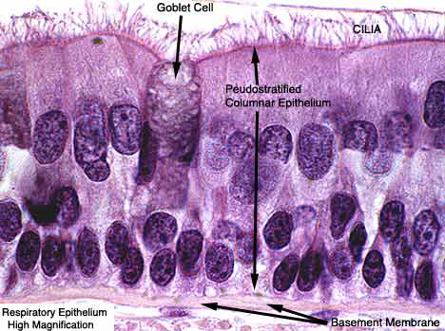
B
A
C
Identify cilia, goblet cell, and epithelium:
A.
B.
C.

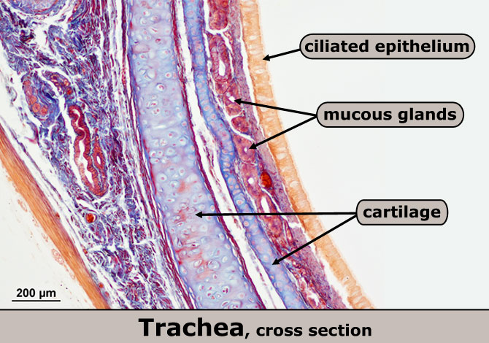
A
B
C
Identify ciliated epithelia, mucous glands and cartilage in the cs of the trachea:
A.
B.
C.

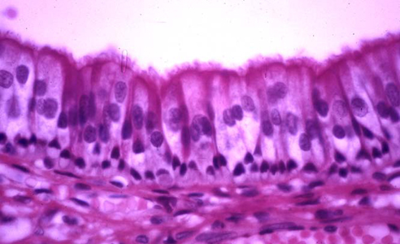
Make a detailed high power drawing of ciliated epithelial cells (only the section between the lines):
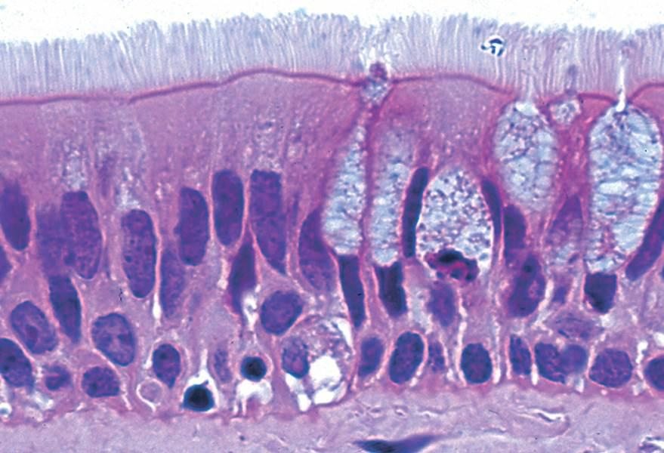
Make a detailed, high power drawing of a few goblet cells with cilia (only the section between the lines):

The top of this cross section of the trachea is the anterior portion, while the bottom includes the trachealis muscle, which holds the posterior ends of the C-shaped cartilages in place. The esophagus would be below this section, if it were shown.
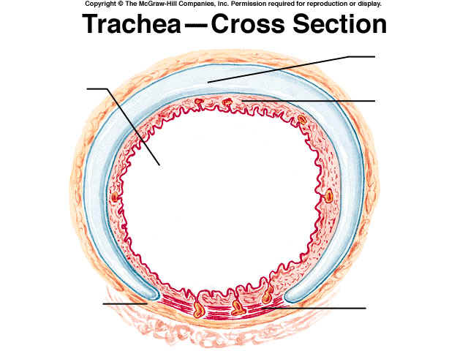
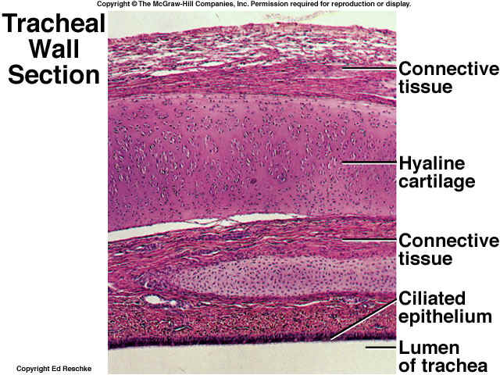

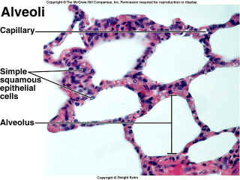
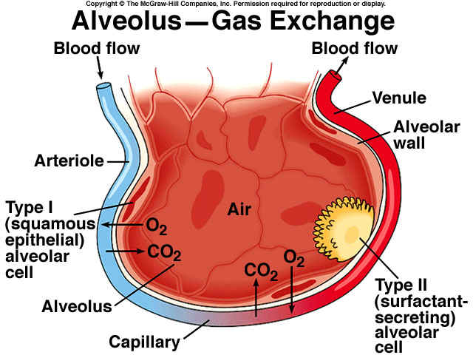

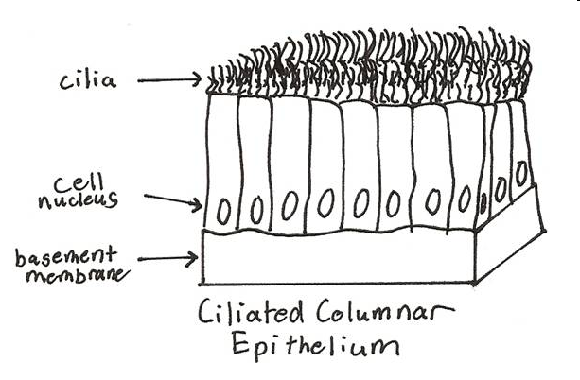

Useful websites:
www.courseweb.uottawa.ca/medicine-histology/english/respiratory/Default.htm#Fig%2018
www.gwc.maricopa.edu/class/bio202/Respiratory/NormalA.htm
www.histologyguide.org/Slide_Box/17_Respiratory_System.html
www.histology.leeds.ac.uk/respiratory/conducting.php

