1. The transport system in mammals is a double circulatory system driven by a pump
(the heart).
Explain what is meant by a double circulatory system.
..................................................................................................................................
..................................................................................................................................
..................................................................................................................................
..................................................................................................................................
[Total 2 marks]

2. The diagram below gives information about the relative thickness of the walls of three chambers of the heart:
• left ventricle
• right ventricle
• right atrium
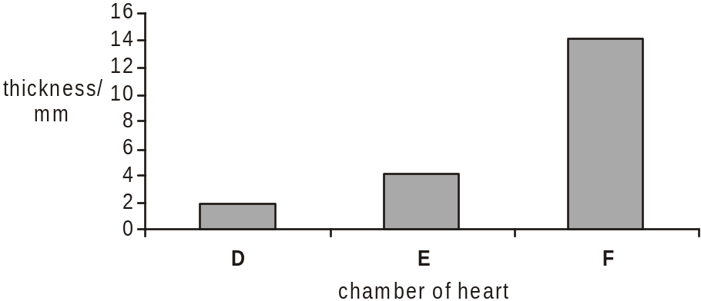

(i) State which of these chambers are identified by the letters D, E and F.
D .....................................................................................................................
E .....................................................................................................................
F .....................................................................................................................
[3]

(ii) Explain, with reference to its function, why the wall of chamber F is much thicker than the walls of chambers D and E.
.........................................................................................................................
.........................................................................................................................
.........................................................................................................................
.........................................................................................................................
.........................................................................................................................
.........................................................................................................................
[3]
[Total 6 marks]

3. Use the most appropriate terms to complete the paragraph below about the role of haemoglobin in the mammalian blood.
Haemoglobin, a pigment found in the blood of mammals, has an important role in the
transport of respiratory gases. Each haemoglobin molecule contains haem groups. In the
lungs, oxygen binds with the atom of ………………………… in each haem group. The
maximum number of molecules of oxygen that can be carried by one molecule of
haemoglobin is ………………………… . In areas like muscle tissue where the partial
pressure of oxygen is low, oxygen dissociates from the haem group. This dissociation is
increased by the presence of carbon dioxide; this is called the …………………………
………………………… . Most of the carbon dioxide produced in respiring tissues diffuses
into the red blood cells where the enzyme ………………………… ……………………
catalyses a reaction leading to the production of hydrogen ions and hydrogen carbonate
ions. The hydrogen ions combine very readily with haemoglobin to form a compound
known as ………………………… ………………………… . The effect of this is to increase
the release of oxygen from haemoglobin.
[Total 5 marks]

4. A student was studying the surface area to volume ratio of three unicellular organisms, A, B and C, from the same habitat. The diagram below shows the three organisms and some of the calculations the student made.
scale:  0.075 mm | A   | B  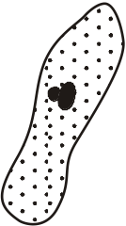 | C  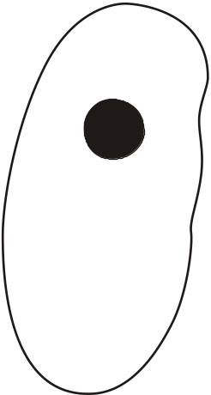
surface area / mm2 | 0.28 | 3.1 | 23
volume / mm3 | 0.02 | 0.59 | 11.3
surface area to  volume ratio | 14:1 |  | 2:1
Adapted data © M Jones and G Jones, Advanced Biology, 1997, Cambridge University Press

(a) (i) Calculate the surface area to volume ratio for organism B to the nearest whole number.
Write your answer in the shaded box in the table.
[1]
(ii) By how many times does the surface area to volume ratio for organism C differ from that for organism A?
................................................................................................................
[1]

(b) The student determined the rate of oxygen uptake for the three organisms in cm3 of oxygen g–1 h–1. The student found that the results were:
1.0 cm3 g–1 h–1
0.5 cm3 g–1 h–1
7.0 cm3 g–1 h–1
State which of the three figures is most likely to be the value for the rate of oxygen uptake for organism C.
.........................................................................................................................
[1]

(c) None of the organisms A, B or C has a transport system.
Explain why organisms larger than organism C need to have transport systems.
.........................................................................................................................
.........................................................................................................................
.........................................................................................................................
.........................................................................................................................
.........................................................................................................................
.........................................................................................................................
[3]
[Total 6 marks]

5. The table below contains some terms or names of structures related to the mammalian heart and circulatory system.
Complete the table by selecting the statement from the list A to I below that best matches the term or structure in the table.
The first one has been done for you.
You may use each letter once, more than once or not at all.
term or structure | statement
a closed system | A
a double circulation
Purkyne tissue
fibrous tissue between the atria and the ventricles
atrioventricular node (AVN)
sinoatrial node (SAN)
coronary artery

A the blood flows in vessels
B the left and right side of the heart contract at different times
C transmits waves of excitation to the base of the heart
D initiates the cardiac cycle
E is unable to conduct waves of excitation
F carries oxygen to the heart muscle
G conducts waves of excitation over the walls of the ventricles
H blood passes twice through the heart for one complete circuit of the body
I delays transmission of the waves of excitation by about 0.1 s
[Total 6 marks]

6. Below is a diagram of blood showing both red and white blood cells.
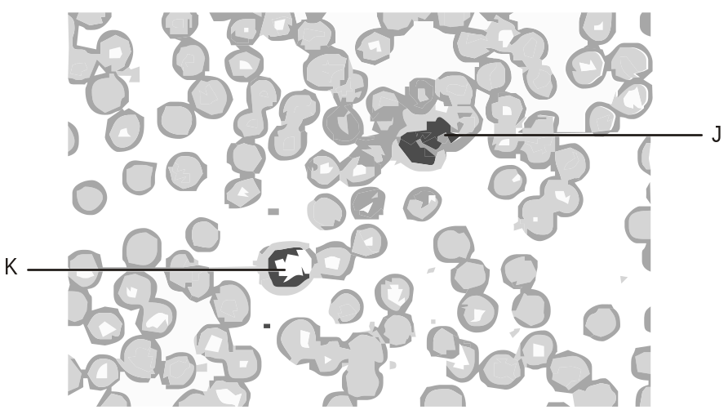

Complete the table below to give the name and function of the white blood cells labelled J and K.
cell | name | function
J
K

[Total 4 marks]

7. In this question, one mark is available for the quality of spelling, punctuation and grammar.
Below is a diagram of blood showing both red and white blood cells.
Describe how red blood cells, such as those shown in the photograph, are adapted for their function.
(Allow one lined page).
[6]
Quality of Written Communication [1]
[Total 7 marks]

8. The diagram below shows an artery lying on the surface of living heart muscle as seen by an instrument called an endoscope. The lumen of the artery has become narrowed at the point labelled Y.
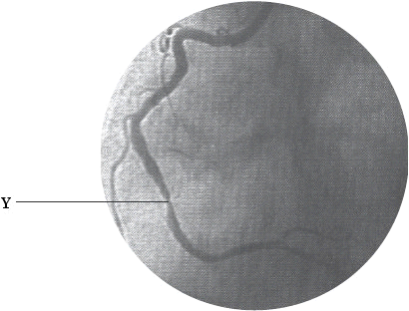
The Forum on Ischaemic Heart Disease.
Reproduced by kind permission of Dr Graham Jackson,
Cardiology Unit, Guy’s and St Thomas’ Hospital.
(i) Name the artery shown in the diagram.
.........................................................................................................................
[1]

(ii) Explain how the lumen of the artery has become narrowed at point Y.
.........................................................................................................................
.........................................................................................................................
.........................................................................................................................
.........................................................................................................................
[2]
[Total 3 marks]

9. (i) Suggest how doctors might treat a patient with narrowing of the arteries that supply the heart muscle.
.........................................................................................................................
.........................................................................................................................
.........................................................................................................................
.........................................................................................................................
[2]

(ii) Suggest two pieces of advice that a doctor might give to such a patient to try to reduce the likelihood of further narrowing of the arteries.
1 ......................................................................................................................
.........................................................................................................................
2 ......................................................................................................................
.........................................................................................................................
[2]
[Total 4 marks]

10. The diagram below shows the changes in the pressure of blood as it flows through various parts of the mammalian blood system.
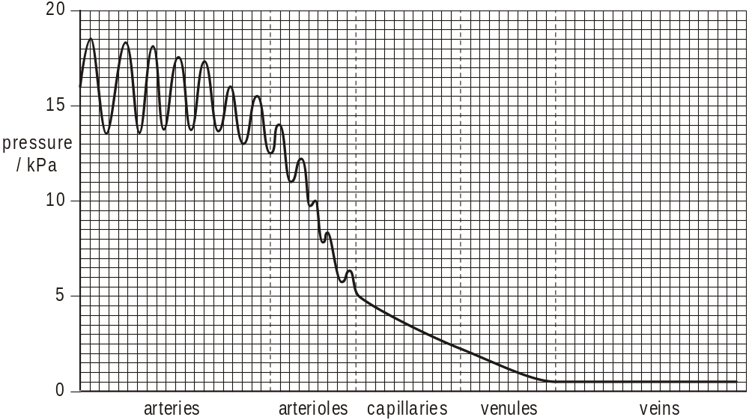

(a) The diagram shows that the pressure rises and falls in the arteries.
Explain what causes this rise and fall in pressure.
.........................................................................................................................
.........................................................................................................................
.........................................................................................................................
.........................................................................................................................
[2]

(b) The diagram shows that:
• the rise and fall in pressure seen in the arteries is not evident by the time the blood enters the capillaries
• the pressure is much lower by the time the blood enters the capillaries.
Explain what causes the changes described above.
.........................................................................................................................
.........................................................................................................................
.........................................................................................................................
.........................................................................................................................
.........................................................................................................................
.........................................................................................................................
[3]

(c) Explain why it is important that the pressure is lower by the time blood reaches the capillaries.
.........................................................................................................................
.........................................................................................................................
.........................................................................................................................
.........................................................................................................................
.........................................................................................................................
[2]

(d) The pressure in veins is very low. Explain how the blood in veins is returned to the heart.
.........................................................................................................................
.........................................................................................................................
.........................................................................................................................
.........................................................................................................................
.........................................................................................................................
.........................................................................................................................
[2]
[Total 9 marks]

11. The diagram below is a vertical section of the heart to show the position of certain structures. The diagram also shows a minor heart defect called patent foramen ovale (PFO).
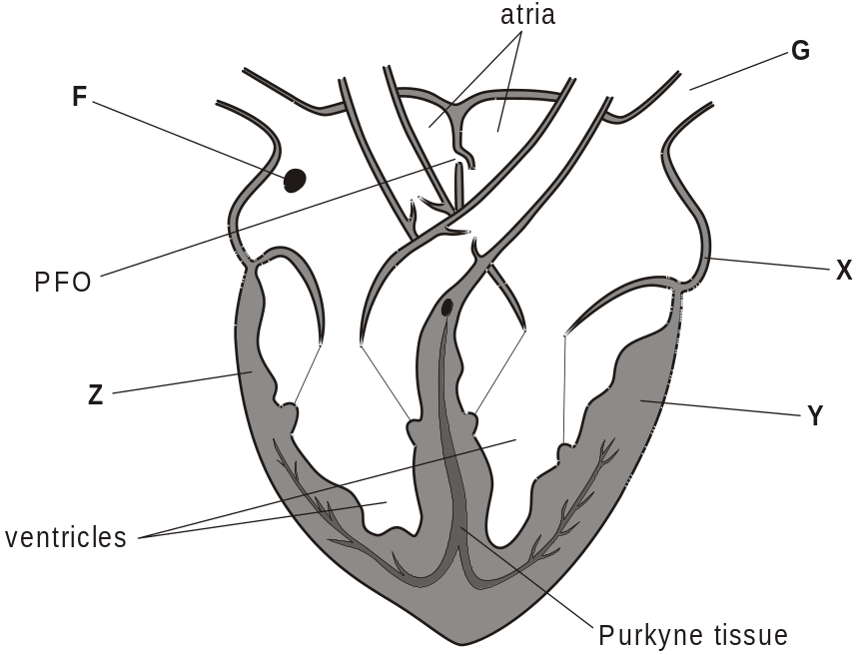

(a) State the names of structures F and G.
F ......................................................................................................................
G .....................................................................................................................
[2]

(b) The statements below were made to a group of students.
Explain why each statement is true.
(i) The difference in thickness of the walls of the chambers, as shown by the letters X, Y and Z, is related to the functions of the different chambers.
................................................................................................................
................................................................................................................
................................................................................................................
................................................................................................................
................................................................................................................
................................................................................................................
[3]

(ii) Without the Purkyne tissue, blood would not be pumped out of the heart efficiently.
................................................................................................................
................................................................................................................
................................................................................................................
................................................................................................................
[2]

(c) Recent research has shown that there may be a link between migraines (severe headaches) and the minor heart defect PFO. In PFO the small flap shown in the diagram fails to close completely at birth.
Suggest how PFO might lead to a migraine.
.........................................................................................................................
.........................................................................................................................
.........................................................................................................................
.........................................................................................................................
.........................................................................................................................
.........................................................................................................................
[3]
[Total 10 marks]

12. (a) Two slightly different types of haemoglobin are found in mammals. Fetal haemoglobin is found in the developing fetus, but is replaced by adult haemoglobin. In humans, this replacement is completed by the time a baby is six months old.
The diagram below shows the change in the percentage of each type of haemoglobin for six months before birth and for eight months after birth.
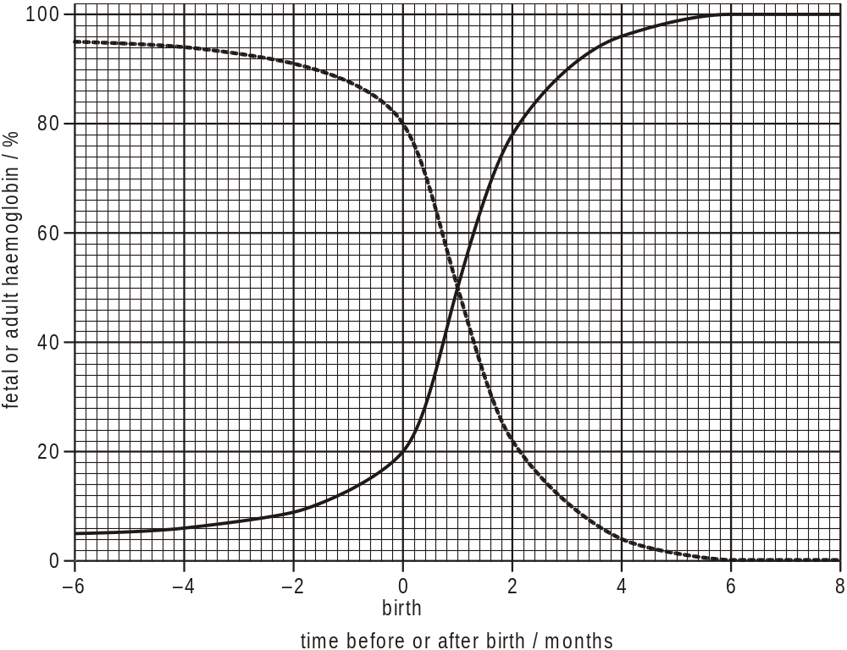
State the percentage of adult haemoglobin present when the baby is two months old.

Answer = ........................................%
[1]

(b) (i) Explain why it is essential that the fetus has a different type of haemoglobin from the adult.
................................................................................................................
................................................................................................................
................................................................................................................
................................................................................................................
................................................................................................................
................................................................................................................
................................................................................................................

(ii) Explain why the change from fetal to adult haemoglobin seen in the diagram above is essential after birth.
................................................................................................................
................................................................................................................
................................................................................................................
................................................................................................................
[5]
[Total 6 marks]

13. Use the most appropriate terms to complete the paragraph below about the transport of gases in the blood.
Respiring tissues in the body produce carbon dioxide which diffuses into the blood.
Most of it then enters red blood cells where an enzyme named ......................................
................................................ catalyses a reaction to produce .................................... .
This dissociates rapidly into hydrogen ions and ...................................................... ions.
The hydrogen ions combine very readily with haemoglobin to form a compound known
as ........................................................ . There are two effects of this reaction.
1 Hydrogen ions are removed from the blood making it less acidic.
2 As haemoglobin picks up the hydrogen ions it releases ....................................... .
[Total 5 marks]

14. A student was told by a teacher that the surface area to volume ratio (SA:V ratio) of an organism varies according to its size. The student decided to investigate this using two spheres, A and B, as models of organisms of different sizes. These are shown in the table below. The surface area and volume of each sphere were calculated.
 | sphere A | sphere B
 |  | 
diameter/ cm | 1 | 3
surface area/ cm2 | 3.14 | 28.27
volume / cm3 | 0.52 | 14.14

(a) (i) The student calculated the SA:V ratio of sphere B as 2:1. Calculate the SA:V ratio of sphere A. Show your working.

Answer = ...............................................................
[2]

(ii) Describe how the SA:V ratio changes as the size of the sphere increases.
................................................................................................................
................................................................................................................
................................................................................................................
................................................................................................................
[2]

(b) The teacher also told the student that differences in the SA:V ratio, such as those seen between sphere A and sphere B, have influenced the need for transport systems.
Explain how such differences have influenced the need for transport systems in mammals.
.........................................................................................................................
.........................................................................................................................
.........................................................................................................................
.........................................................................................................................
.........................................................................................................................
.........................................................................................................................
[3]

(c) There are several parts of the mammalian body where the surface area is relatively large to allow effective functioning.
State one example of such a part of the mammalian body.
.........................................................................................................................
[1]
[Total 8 marks]

15. The diagram below shows the pressure changes in the aorta, left ventricle and left atrium during one cardiac cycle.
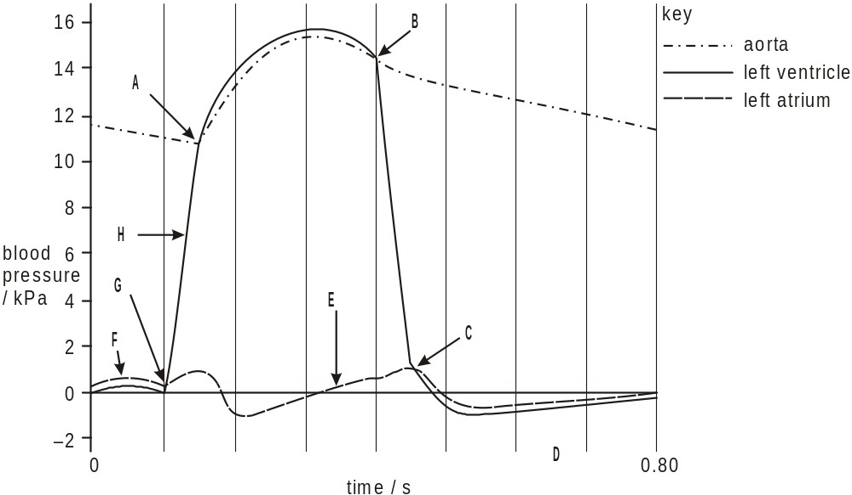

In the table below, match up each statement with an appropriate letter from A to H on the diagram. One has been done for you.
You may use each letter once, more than once or not at all.
statement | letter
semilunar (aortic) valve starting to open | A
atrio-ventricular (bicuspid) valve about to open
semilunar (aortic) valve about to close
atrio-ventricular (bicuspid) valve about to close
left ventricle starting to contract
both left atrium and left ventricle relaxing
minimum blood volume in left ventricle
[Total 6 marks]

16. Complete the following paragraph on the control of the cardiac cycle using the most appropriate word or words.
Heart wall muscle is a special type of muscle called .............................. muscle. This
muscle can contract or relax without nervous stimulation and is thus described as
..................................................... . To ensure that the cardiac cycle stays in sequence
there is an in-built control mechanism. The wall of the right atrium contains a special
region of muscle called the .................................................... which sets up a wave of
electrical activity causing the atrial walls to contract almost simultaneously. There is a
band of fibres between the atria and ventricles which ........................................ the
wave of activity passing to the ventricle walls. The wave of activity is picked up by the
.......................................................... situated in the septum at the junction of the atria
and ventricles. The wave of activity then passes down the septum in the
.............................................................. causing the ventricles to contract.
[Total 6 marks]

17. The changes in electrical activity that occur in the muscle of the heart wall during the cardiac cycle can be recorded as an electrocardiogram (ECG).
Fig. 1 shows a normal ECG.
• P represents activity in the atrial walls.
• R represents the contraction of the ventricles.
• T represents the recovery of the ventricle walls.
Fig. 2 shows an ECG from a person who has entered a condition known as fibrillation.

Fibrillation should be treated rapidly to increase the chances of survival.
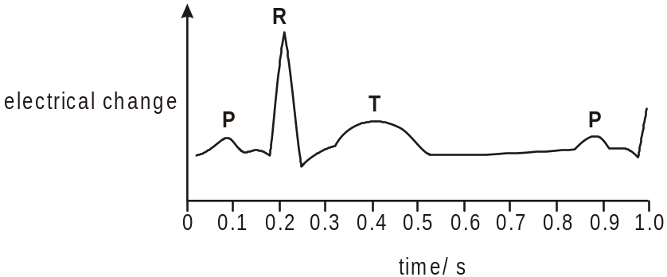
Fig. 1
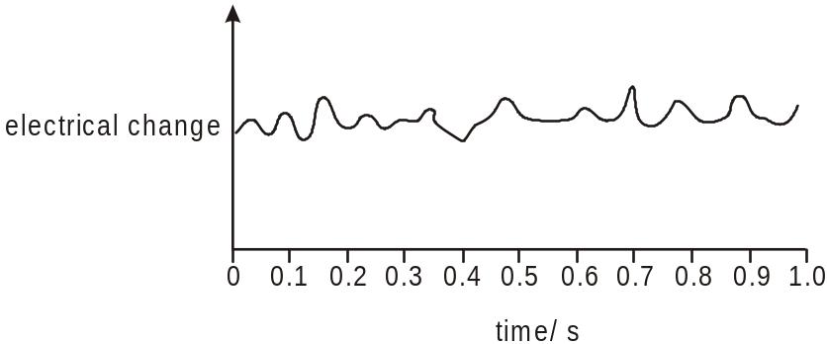
Fig. 2

Using the information in Figs. 1 and 2, suggest why a person with a fibrillating heart is unlikely to survive for long if not treated.
..................................................................................................................................
..................................................................................................................................
..................................................................................................................................
..................................................................................................................................
[Total 2 marks]

18. Fig. 1 shows the effect of two different partial pressures of carbon dioxide on the dissociation curve for haemoglobin.
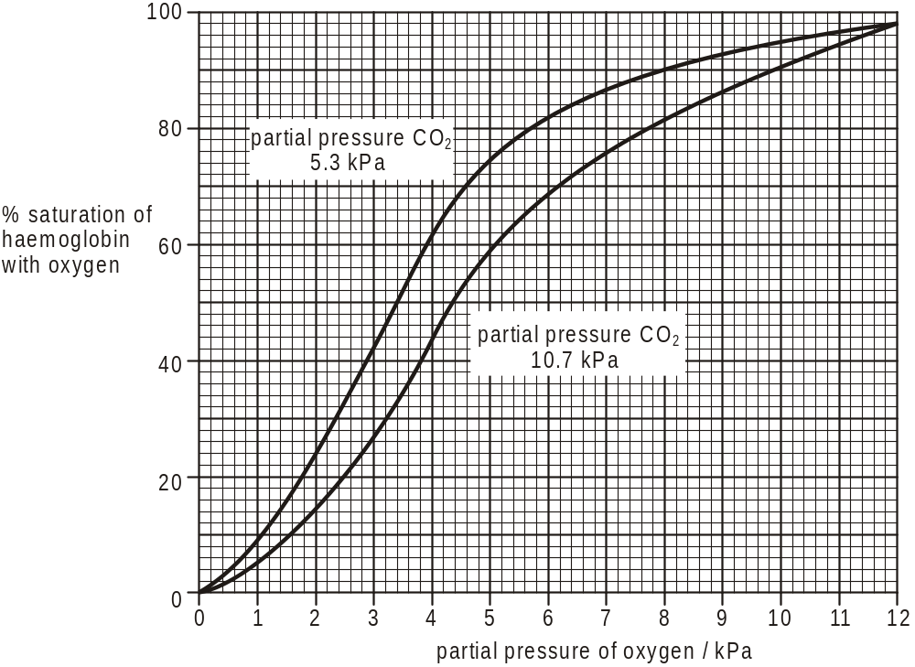
Fig. 1

(a) (i) Name the effect illustrated by the two curves.
................................................................................................................
[1]
(ii) The steepest part of each curve in Fig. 1 is between the oxygen partial pressures of 2 and 5 kPa.
Explain why it is important that this is so.
................................................................................................................
................................................................................................................
................................................................................................................
................................................................................................................
[2]

(iii) Explain how the effect of increasing the partial pressure of carbon dioxide from 5.3 to 10.7 kPa ensures a greater delivery of oxygen to exercising muscle tissue.
................................................................................................................
................................................................................................................
................................................................................................................
................................................................................................................
................................................................................................................
[2]

(b) The effect shown in Fig. 2 also increases the delivery of oxygen to exercising muscle tissue.
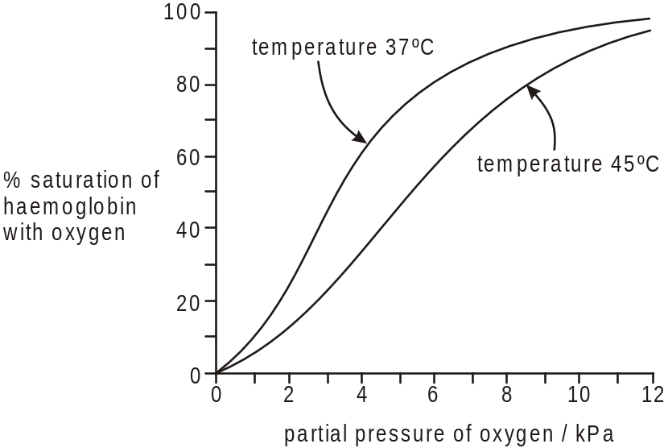
Taken from 'Advanced Human Biology' by J. Simpkins and J.I. Williams
Fig 12.21, p233 (ISBN 0713527692)
Fig. 2

Suggest how exercising muscle tissue can bring about the changes seen in
Fig. 2.
.........................................................................................................................
.........................................................................................................................
.........................................................................................................................
.........................................................................................................................
[2]
[Total 7 marks]

19. (a) The diagram below shows some mammalian blood vessels in cross section.
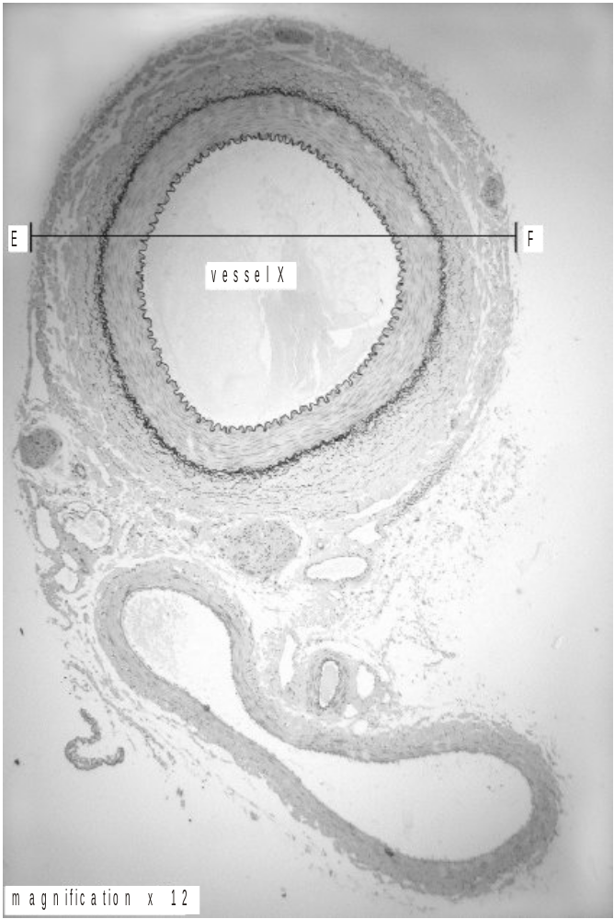
Vessel X is an artery. Its magnification is given on the diagram.

Calculate the actual width of the vessel in mm between points E and F. Show your working and express your answer to the nearest whole number.

Answer = ………………………………… mm
[2]

(b) In this question, one mark is available for the quality of use and organisation of scientific terms.
Describe how the structure of an artery is related to its function.
You may refer to features visible in the diagram above to help in your answer.
(Allow one lined page).
[6]
Quality of Written Communication [1]
[Total 9 marks]

20. The table below contains information about various components of the mammalian circulatory system.
 | blood in  aorta | tissue  fluid | lymph | blood in  vena cava
red blood cells | many |  | none | many
white blood cells |  | some | some | many
glucose concentration | high | high |  | high
pressure | high | low | low
(a) (i) Complete each of the shaded boxes in the table with the most appropriate word.
[4]

(ii) Explain the differences recorded in the table for glucose and pressure.
glucose ...................................................................................................
................................................................................................................
................................................................................................................
................................................................................................................
pressure .................................................................................................
................................................................................................................
................................................................................................................
................................................................................................................
[4]

(b) The blood also contains hydrogen carbonate ions (HCO3–). Describe how these ions are formed in the blood.
.........................................................................................................................
.........................................................................................................................
.........................................................................................................................
.........................................................................................................................
.........................................................................................................................
.........................................................................................................................
[3]
[Total 11 marks]

21. The diagram below shows an external view of a human heart as seen from the front.
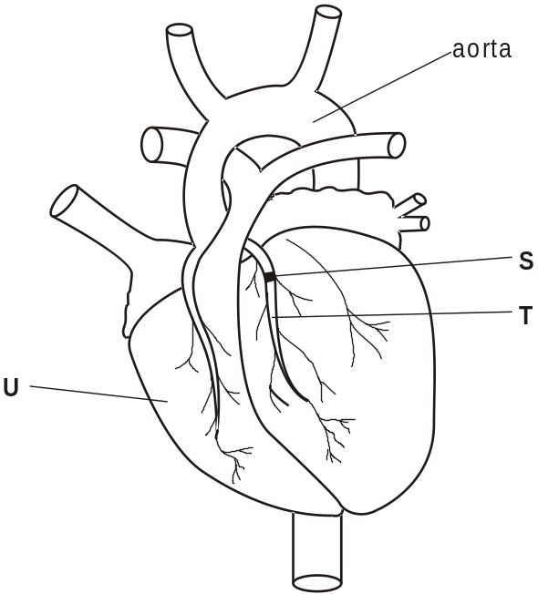

(i) Name the structures T and U.
T ......................................................................................................................
U .....................................................................................................................
[2]

(ii) Suggest the consequences of a blockage at point S as shown on the diagram.
.........................................................................................................................
.........................................................................................................................
.........................................................................................................................
.........................................................................................................................
[2]
[Total 4 marks]

22. Figs. 1 and 2 are diagrams to show the internal structure of the heart and its associated circulatory system in a simplified form. Fig. 1 represents the system for a mammal and Fig. 2 that for a frog (an amphibian).
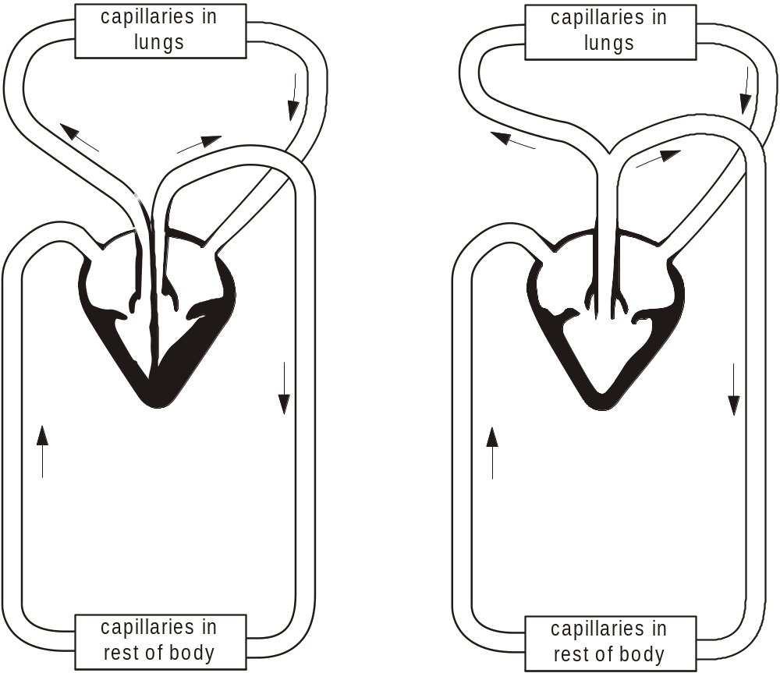
mammal frog
Fig. 1 Fig. 2
Both systems are described as closed systems. The mammalian system is also described as a complete double circulation but the frog as a partial double circulation.

(i) State what is meant by a closed system.
.........................................................................................................................
.........................................................................................................................
[1]

(ii) Use the information in Fig. 1 and Fig. 2 to suggest why the mammalian system is called a complete double circulation whilst that of the frog is called a partial double circulation.
.........................................................................................................................
.........................................................................................................................
.........................................................................................................................
.........................................................................................................................
.........................................................................................................................
.........................................................................................................................
.........................................................................................................................
.........................................................................................................................
[3]

(iii) Suggest why the system shown for the frog may be less effective at supplying the body tissues with oxygen.
.........................................................................................................................
.........................................................................................................................
.........................................................................................................................
.........................................................................................................................
.........................................................................................................................
[2]
[Total 6 marks]

23. Lugworms are common animals that burrow in the sand of the seashore, just above the low tidemark. They are found where there is mild wave action and where the sand is rich in organic matter. The main external features of a lugworm are shown in Fig. 1.
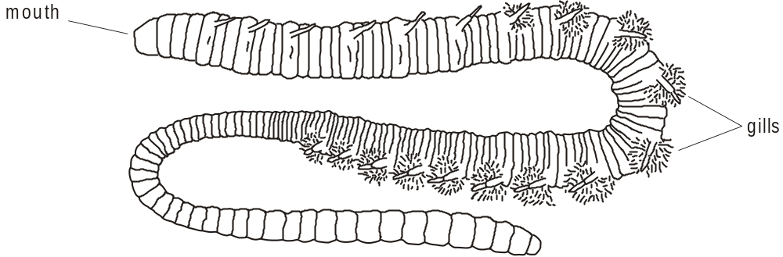
Fig. 1

Each lugworm makes a U-shaped burrow which reaches the surface in two places, as shown in Fig. 2.
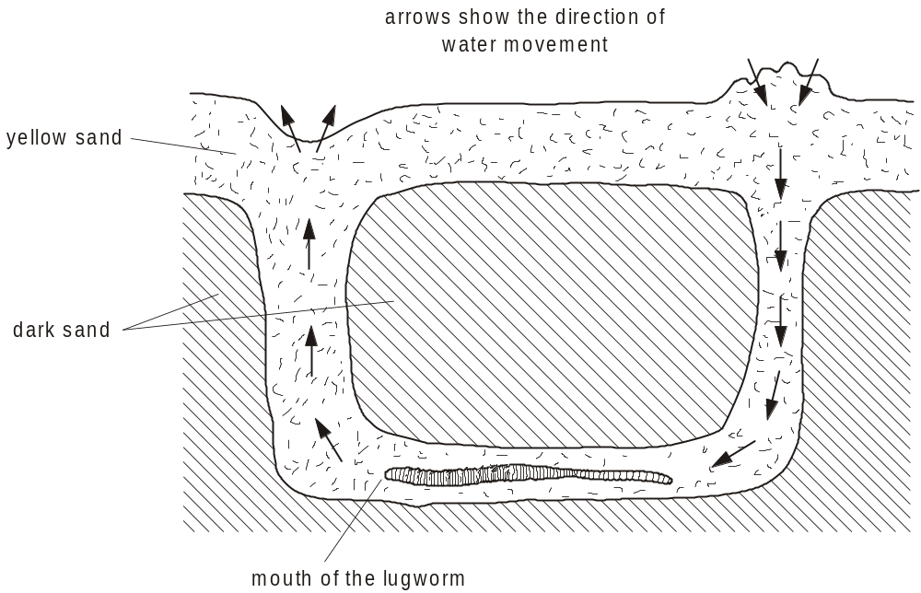
Fig. 2

While the beach is covered by the tide, the lugworm moves its body so that a current of seawater passes down the burrow, over the worm and up through the porous sand, in the direction shown. These ventilation movements allow water to flow slowly past the tufts of gills. The gills are feathery outgrowths of the body wall and appear dark red because they contain many small blood vessels.
A lugworm’s blood plasma has a high concentration of haemoglobin dissolved in it. There are no red blood cells. Fig. 3 shows dissociation curves for lugworm haemoglobin and for human haemoglobin.
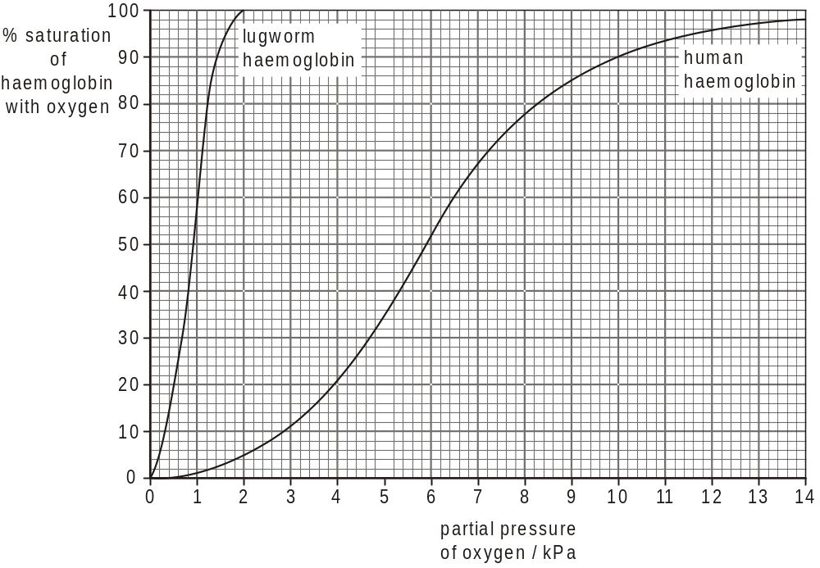
Fig. 3

(a) Describe and explain one way in which the dissociation curve for lugworm haemoglobin differs from that for human haemoglobin.
difference ........................................................................................................
.........................................................................................................................
explanation ......................................................................................................
.........................................................................................................................
[2]

(b) In this question, one mark is available for the quality of spelling, punctuation and grammar.
Describe the similarities and differences between the adaptations for gas exchange and transport of oxygen in mammals and lugworms.
You will gain credit for using information given in question 4.
(Allow one lined page)
[7]
Quality of Written Communication [1]
[Total 12 marks]

24. Use the most appropriate terms to complete the paragraph below about the role of haemoglobin.
Haemoglobin is a pigment found in the blood of mammals which has an important role
in the transport of respiratory gases. Each haemoglobin molecule contains haem
groups. In the lungs, oxygen binds with the atom of ………………………… in each
haem group. The maximum number of molecules of oxygen that can be carried by one
molecule of haemoglobin is ………………………… . In areas like muscle tissue where
the partial pressure of oxygen is low, oxygen dissociates from the haem group. This
dissociation is increased by the presence of carbon dioxide; this is called the
………………………… ………………………… . Most of the carbon dioxide produced in
respiring tissues diffuses into the red blood cells where the enzyme ……………………
………………………… catalyses a reaction leading to the production of hydrogen ions
and hydrogen carbonate ions. The hydrogen ions combine very readily with
haemoglobin to form a compound known as ……………………… ……………………….
The effect of this is to increase the release of oxygen from haemoglobin.
[Total 5 marks]

25. The diagram below shows a mammal and a unicellular organism. The transport system in mammals is a double circulatory system driven by a pump (the heart), whilst unicellular organisms have no need for special transport systems.
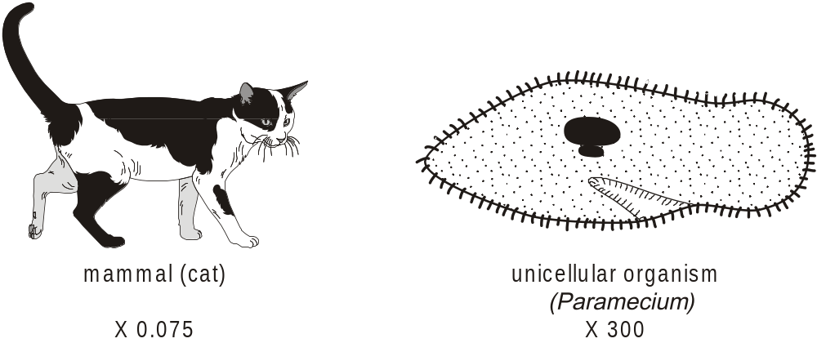

(i) Explain what is meant by a double circulatory system.
.........................................................................................................................
.........................................................................................................................
.........................................................................................................................
.........................................................................................................................
[2]

(ii) Explain two reasons why mammals need a circulatory system whilst unicellular organisms, such as that shown in the diagram, do not.
first reason ......................................................................................................
.........................................................................................................................
.........................................................................................................................
.........................................................................................................................
second reason ................................................................................................
.........................................................................................................................
.........................................................................................................................
.........................................................................................................................
[4]
[Total 6 marks]

26. The cardiac cycle is the sequence of events which makes up one heart beat. The diagram below shows the events in the heart during one heart beat. The heart is viewed from the side.
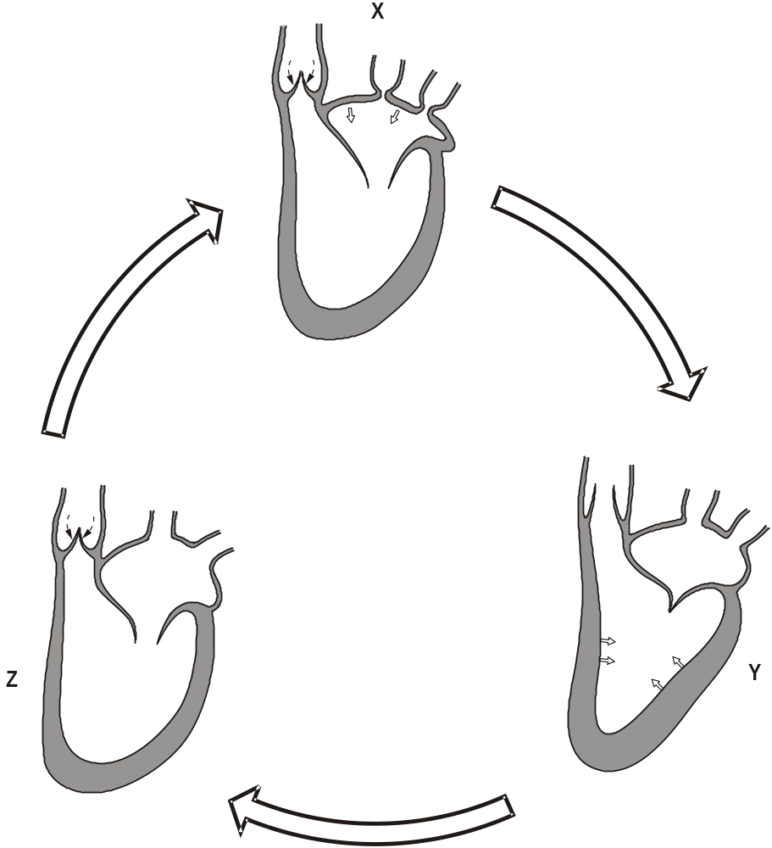

In this question, one mark is available for the quality of spelling, punctuation and grammar.
Using the information in the diagram, describe the sequence of events involved in one heart beat.
You may annotate X, Y and Z in the diagram to help your answer. (Do not describe how the beat is initiated and controlled.)
(Allow one lined page).
[6]
Quality of Written Communication [1]
[Total 7 marks]

27. (a) Fig. 1 shows the changes in blood pressure as blood flows through various parts of the mammalian blood system.
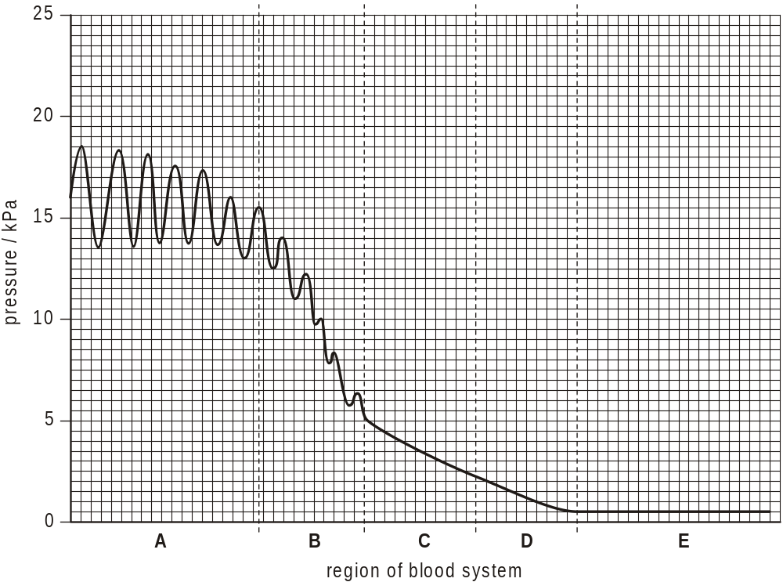
Fig. 1

(i) Calculate the drop in blood pressure from the start of region B to the end of region D. Show your working.

Answer =………………………… kPa
[2]

(ii) Explain what brings about the drop in pressure between B and D.
................................................................................................................
................................................................................................................
................................................................................................................
................................................................................................................
................................................................................................................
[2]

(iii) Suggest why it is important that the pressure in region C is not as great as the pressure in region A.
................................................................................................................
................................................................................................................
................................................................................................................
................................................................................................................
[2]

(b) Fig. 2 shows the structure of part of a capillary.
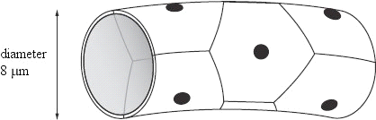
Fig. 2

(i) State which of the regions A to E shown on Fig. 1 represents the capillaries.
................................................................................................................
[1]

(ii) Select two structural features of capillaries and explain how each feature helps with the exchange of materials between the blood and the tissue fluid.
feature ....................................................................................................
role in exchange .....................................................................................
................................................................................................................
................................................................................................................
feature ....................................................................................................
role in exchange .....................................................................................
................................................................................................................
................................................................................................................
................................................................................................................
[4]
[Total 11 marks]

28. (a) Oxygen is carried around the bodies of mammals, bound reversibly to the pigment haemoglobin. The pigment is found in both adult and fetal red blood cells.
The graph below shows the dissociation curves for maternal and fetal oxyhaemoglobin.
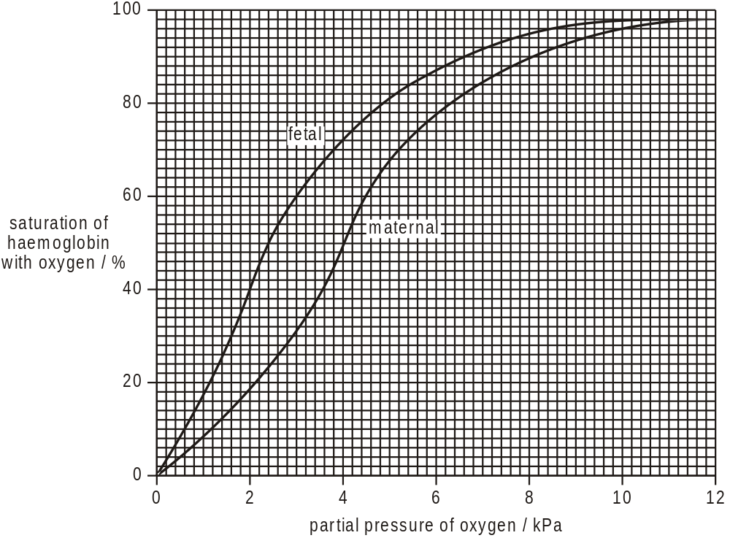

(i) State the difference in the percentage saturation of haemoglobin with oxygen between the fetal and the maternal blood at an oxygen partial pressure of 3 kPa.
................................................................................................................
[1]

(ii) Explain why the difference between the two curves is essential for the survival of the fetus.
................................................................................................................
................................................................................................................
................................................................................................................
................................................................................................................
................................................................................................................
................................................................................................................
................................................................................................................
[4]

(b) After birth, the adult form of haemoglobin gradually replaces the fetal form of haemoglobin.
Suggest why this is necessary.
.........................................................................................................................
.........................................................................................................................
.........................................................................................................................
.........................................................................................................................
[2]
[Total 7 marks]

29. The diagram below shows the internal structure of the mammalian heart and associated blood vessels.
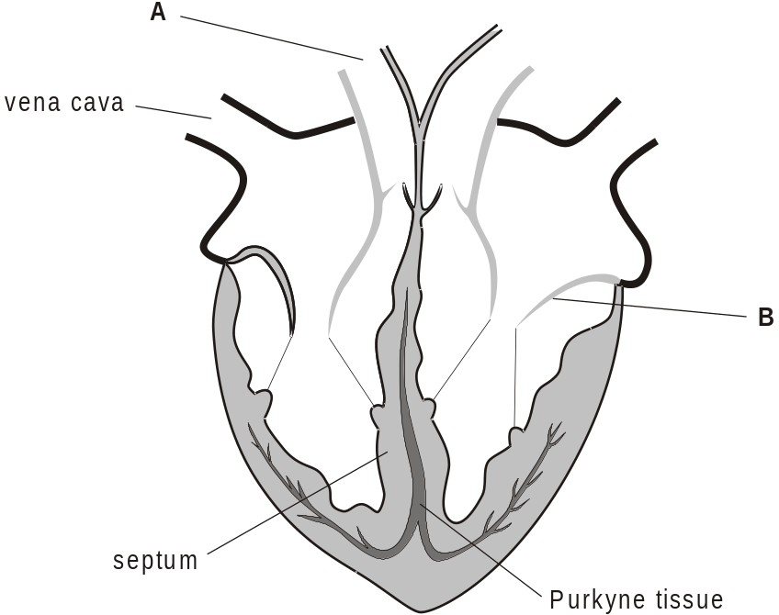

(i) State the name of structures A and B.
A .....................................................................................................................
B .....................................................................................................................
[2]
(ii) Use arrows on the diagram to show the direction of blood flow through the left side of the heart.
[1]

(iii) Suggest how the heart would be affected if the Purkyne tissue ceased to function.
.........................................................................................................................
.........................................................................................................................
.........................................................................................................................
.........................................................................................................................
.........................................................................................................................
.........................................................................................................................
[2]

(iv) The septum shown on the diagram completely separates the left and right sides of the heart.
Explain why it is important that the two sides of the heart are completely separated.
.........................................................................................................................
.........................................................................................................................
.........................................................................................................................
.........................................................................................................................
.........................................................................................................................
.........................................................................................................................
[2]
[Total 7 marks]

30. In this question, one mark is available for the quality of spelling, punctuation and grammar.
The diagram below shows the internal structure of the mammalian heart and associated blood vessels.
Veins, such as the vena cava shown on the figure above, all have a similar structure. Describe the structure of veins and explain how their structure is related to their function.
(Allow one lined page).
[6]
Quality of Written Communication [1]
[Total 7 marks]

31. Read the following passage carefully, then answer the questions below.
Rhizobium is a bacterium that is closely associated with the roots of certain
plants known as legumes. These plants produce chemicals to attract the
bacteria and extra root hairs are produced. The bacteria attach to the surface
of the root hairs. Chemical links are formed between a complex
5 polysaccharide on the bacterial surface and lectin, a protein, formed by the
plants. The bacteria penetrate the cell walls of the root hairs and enter the
cells. The presence of the bacteria stimulates the cells of the root to divide,
forming swellings known as nodules.
The bacteria produce an enzyme, nitrogenase, that is the catalyst for the
10 conversion of nitrogen gas to ammonia. The bacteria use carbon compounds
manufactured by the plant to respire, making energy available for this
conversion. The ammonia is then used to form amino acids. Nitrogenase only
functions in low oxygen concentrations. The root cells produce a pigment,
leghaemoglobin, that is very similar to haemoglobin. Leghaemoglobin absorbs
15 oxygen, leaving low concentrations in the nodules.

(i) Rhizobium is a prokaryotic organism.
State one characteristic that is typical of prokaryotes, but not of eukaryotes.
.........................................................................................................................
.........................................................................................................................
[1]

(ii) Lectin (line 5) and polysaccharides are compounds that are formed from small molecules joined together by chemical bonds.
Explain how the small molecules are joined together to form these compounds.
.........................................................................................................................
.........................................................................................................................
.........................................................................................................................
.........................................................................................................................
[3]

(iii) Leghaemoglobin contains the same metal element as haemoglobin.
Name this metal element.
.........................................................................................................................
[1]

(iv) State the names of two proteins, other than lectin, mentioned in the passage.
1 ......................................................................................................................
2 ......................................................................................................................
[2]

(v) Name the process that occurs in Rhizobium to convert nitrogen gas into ammonia.
.........................................................................................................................
[1]

(vi) It has been suggested that oxygen is an inhibitor of nitrogenase.
Explain one way in which oxygen could act as an inhibitor.
.........................................................................................................................
.........................................................................................................................
.........................................................................................................................
.........................................................................................................................
[2]
[Total 10 marks]

32. The diagram below shows the formation and drainage of tissue fluid in a mammal.
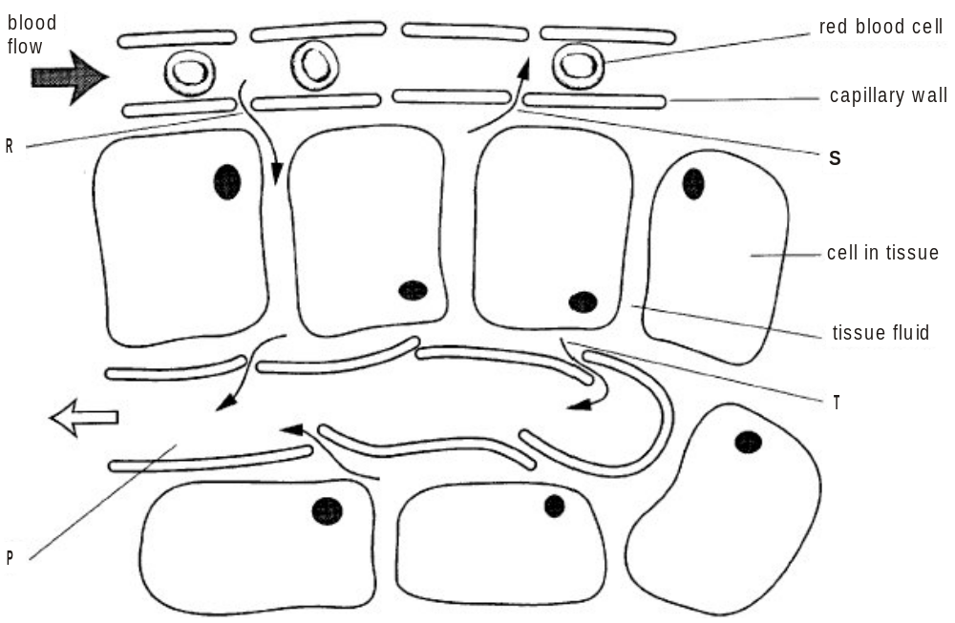

(a) (i) Complete the table to give three differences between tissue fluid and blood.
tissue fluid | blood
[3]

(ii) Name the type of vessel labelled P in the diagram.
................................................................................................................
[1]

(b) In this question, one mark is available for the quality of written communication.
Describe how tissue fluid is formed at R and drained at S and T.
Credit will be given if you use information from the diagram.
(Allow one lined page).
[6]
Quality of Written Communication [1]

(c) Suggest what could happen in the tissues of a person if the drainage at S and T was inefficient.
.........................................................................................................................
.........................................................................................................................
.........................................................................................................................
.........................................................................................................................
[2]
[Total 13 marks]

33. Haemoglobin is a pigment which can combine with oxygen and is found in red blood cells.
The graph below shows the sigmoid (S-shaped) dissociation curve for maternal haemoglobin.
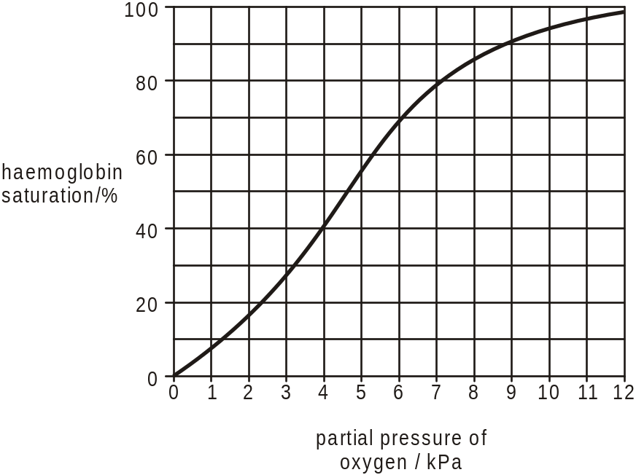
Data from ‘Exchange and Transport’, Fig. 158, p.85, by ABAL.
Published by Cambridge University Press, 1984 (ISBN 0 521 2882 3).

(i) Using the graph, state the likely partial pressure of oxygen in the pulmonary vein leaving the lungs and in a vein leaving a muscle during strenuous exercise.
pulmonary vein ......................... kPa
vein leaving a muscle during strenuous exercise ................................. kPa
[2]
(ii) On the graph, sketch the curve for fetal haemoglobin.
[2]

(iii) Using the graph, explain why it is important that fetal haemoglobin and maternal haemoglobin are different.
.........................................................................................................................
.........................................................................................................................
.........................................................................................................................
.........................................................................................................................
.........................................................................................................................
[3]
[Total 7 marks]

34. Buffers are substances that regulate pH by releasing or accepting hydrogen ions (H+).
Haemoglobin acts as a buffer in the blood.
(i) Describe how the production of carbon dioxide during respiration leads to a higher concentration of hydrogen ions in the blood.
.........................................................................................................................
.........................................................................................................................
.........................................................................................................................
.........................................................................................................................
.........................................................................................................................
.........................................................................................................................
.........................................................................................................................

(ii) Describe how haemoglobin acts to reduce the concentration of hydrogen ions in the blood.
.........................................................................................................................
.........................................................................................................................
.........................................................................................................................
.........................................................................................................................
[Total 4 marks]

35. Below is a simple diagram of a mammalian heart and associated blood vessels as seen in front (ventral) view.
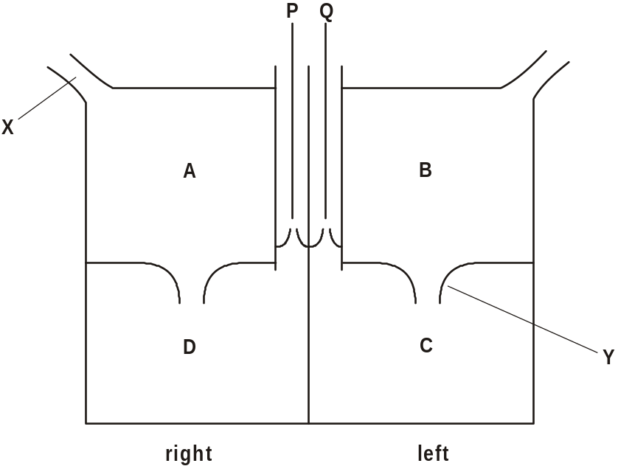

(a) (i) Draw arrows on the diagram to show the direction of blood flow through the left side of the heart.
[1]
(ii) State the name of vessel X and valve Y.
vessel X .................................................................................................
valve Y ...................................................................................................
[2]

(iii) Explain why there are valves at P and Q.
................................................................................................................
................................................................................................................
................................................................................................................
................................................................................................................
................................................................................................................
[2]

(b) The maximum thickness of the external wall of each of the four chambers was measured. The measurements made are shown below.
2 mm 9 mm 16mm 2 mm
(i) From the list of measurements, select the one most likely to correspond to each of the chambers, A, C and D. Write your answers in the table.
chamber | thickness/mm
A
C
D
[3]

(ii) Explain the differences in the wall thickness of chambers A, C and D.
................................................................................................................
................................................................................................................
................................................................................................................
................................................................................................................
................................................................................................................
................................................................................................................
................................................................................................................
[3]

(c) In this question, one mark is available for the quality of written communication.
Describe how the heart beat is initiated and how the contractions of the four chambers are coordinated.
(Allow one and a half lined pages).
[6]
Quality of Written Communication [1]
[Total 18 marks]

36. Peru is a country in South America where people live at a wide range of altitudes. The table below shows:
• the partial pressure of oxygen in the atmosphere at sea level
• the partial pressure of oxygen in the atmosphere at 4 500 m
• the red blood cell count of an adult living at sea level
• the red blood cell count of another adult, born at sea level, but who has lived at 4 500 m for many years.
altitude | partial pressure of  atmospheric oxygen/kPa | red blood cell count/ cells mm–3
sea level | 21 | 5.0 × 106
4 500 m | 15 | 6.4 × 106

(i) Explain what is meant by partial pressure of oxygen, using the figures in the table to help you.
.........................................................................................................................
.........................................................................................................................
.........................................................................................................................
.........................................................................................................................
.........................................................................................................................
[2]

(ii) Describe what would be likely to happen to people who move to high altitude if their red blood cell counts did not increase.
.........................................................................................................................
.........................................................................................................................
.........................................................................................................................
.........................................................................................................................
.........................................................................................................................
.........................................................................................................................
.........................................................................................................................
.........................................................................................................................
.........................................................................................................................
[4]
[Total 6 marks]

37. The synthesis of red blood cells is stimulated by the hormone erythropoetin (EPO) which is secreted by the kidneys. Some long distance athletes have been known to take a course of EPO as part of a training programme.
Suggest why some athletes have taken erythropoetin.
..................................................................................................................................
..................................................................................................................................
..................................................................................................................................
..................................................................................................................................
..................................................................................................................................
[Total 2 marks]

