Class Mammalia

- Evolution of mammals:

- Characteristics of mammals in terms of reproduction and nervous system (brain):

Marine Mammals: (How are these marine mammals different from their land dwelling relatives?)
1. Order Pinnipedia - ex. Seals, sea lions, walrus

a. Sea Lions vs. Seals (fig. 9.9)

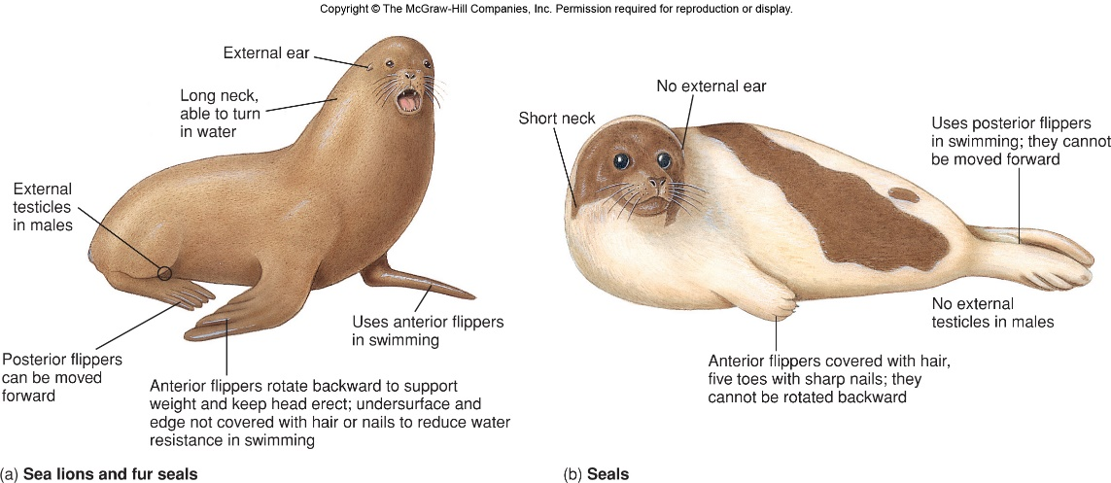

- Order Carnivora – sea otters & polar bears

- Order Sirenia – sea cows (manatees & sea dugongs)

Read the online article “Sleek? Well, No. Complex? Yes, Indeed” and answer the following with your notes in your composition book:
1. Describe the general size of the manatee’s brain and discuss why scientists believe that its brain size may have little to do with its intelligence.

2. Describe how the surface of the manatee’s brain differs from other mammals and discuss why manatee brains may still be rather complex even given this difference.

3. Describe how manatees are related to land mammals and state the manatee’s closest living relatives.

4. State the sensory activity and structures that manatees rely on the most and describe why they rely on this activity the most.

- Order Cetacea – largest group of marine mammals, whales, dolphins & porpoises

a. 2 groups of cetaceans:
- Toothless (baleen) whales

- Toothed whales – dolphins & porpoises, sperm whale, orca

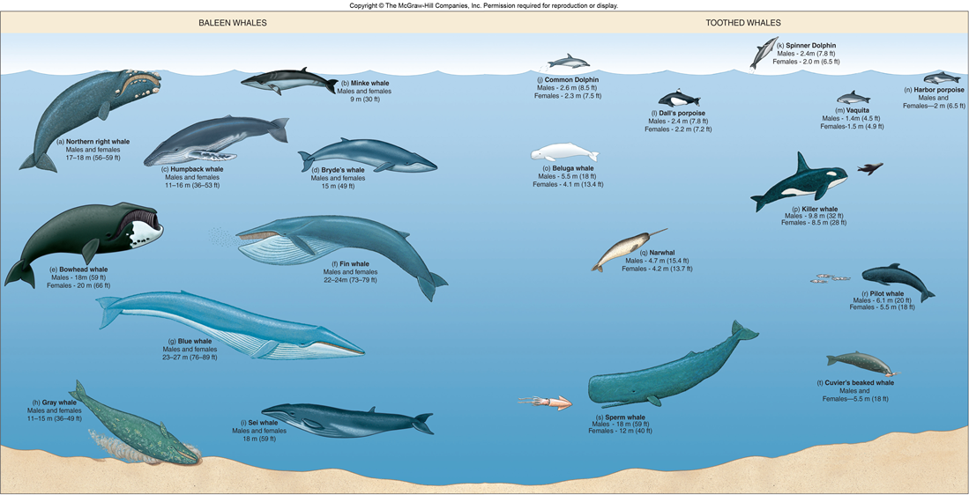

Read “The Whales That Walked To Sea” p. 191 and answer the following with your notes in your composition book:
1. Briefly describe what the oldest known fossil whale, Pakicetus, was like (i.e. how is it similar to a modern cetacean and how is it different?)

2. Briefly describe what Ambulocetus was like (i.e. how is it similar to a modern cetacean and how is it different?)

3. Briefly describe what Basilosaurus was like (i.e. how is it similar to a modern cetaceans and how is it different?)

- Fossils link early cetaceans with what group of animals?

II. Biology of Marine Mammals
A. Diving Adaptations
Read “Diving” p. 199-201 and list in your composition book, the specific adaptations that diving marine mammals have.

B. Echolocation – sensory system based on hearing (nature’s version of sonar)

- Emit sound waves (clicks) which travel 5 times faster in water than in air and listen for echoes that are reflected back from surrounding objects. The time it takes the echoes to return tells the animal how far away the object is, what size it is etc.

C. Behavior – very complex

D. Migrations
Why migrate?

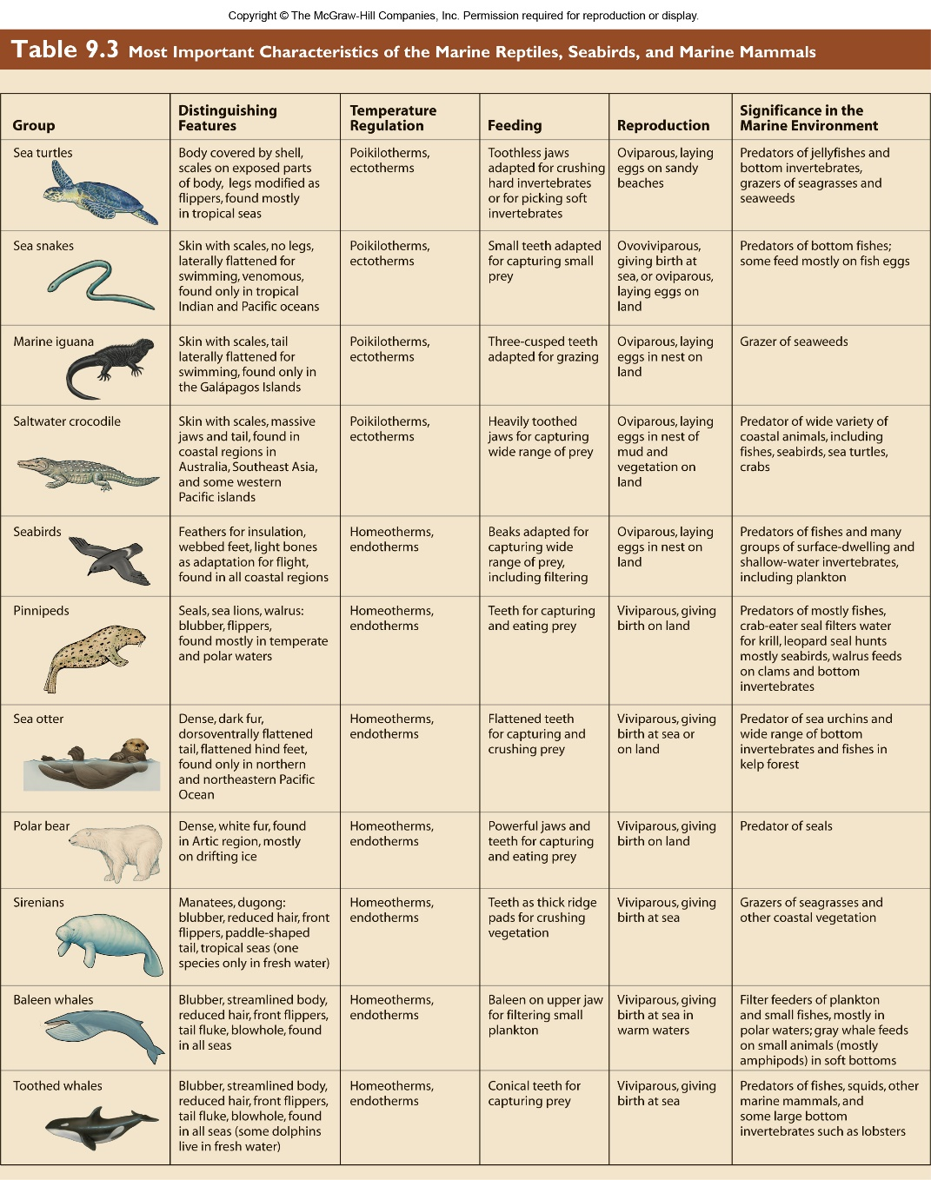

E. Reproduction:

