1.
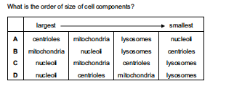

2.
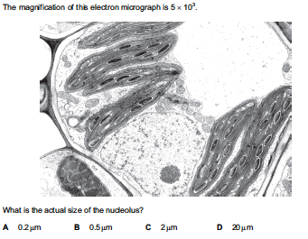

3. Cells which do not have nucleoli die because they do not have
A centrioles and cannot divide.
B mitochondria and cannot release energy.
C mRNA and cannot transcribe DNA.
D ribosomes and cannot synthesise protein.

4.
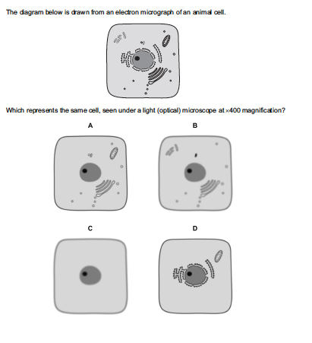

5. Which structures are found in both animal and plant cells?
1 centriole
2 lysosome
3 nucleolus
4 vacuole
A. 1 and 3 only
B. 2 and 4 only
C. 2, 3 and 4 only
D. 1, 2, 3 and 4

6.
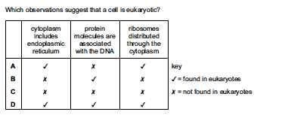

7. A cell organelle measures 4 x 10⁻¹ mm in diameter. What is the diameter in μm?
A 4 x 10¹ μm
B 4 x 10² μm
C 4 x 10³ μm
D 4 x 10⁴ μm

8.
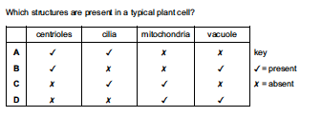
9. Plant cells are stained and then viewed through a light microscope. Which structures would be clearly visible at a magnification of x400?
A chloroplast grana
B lysosomes
C nucleoli
D ribosomes

10. Which range of sizes would include most eukaryotic cells?
A 1 x 10² nm to 1 μm
B 1 μm to 1 x 10¹ μm
C 1 x 10¹ μm to 1 x 10² μm
D 1 x 10² μm to 1 x 10³ μm

11. Which structure is present in all eukaryotic cells but not present in prokaryotic cells?
A 70S ribosome
B cell wall
C chromatin
D plasmid

12.
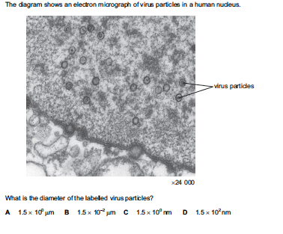
*some scaling issues with this question, pick the answer that is closest to the answer that you calculate

13.
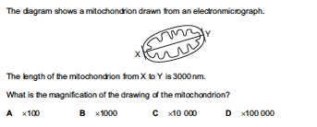
*rounded to the nearest 100

14. What is the function of nucleoli?
A formation and breakdown of the nuclear envelope
B formation of centromeres
C formation of ribosomes
D formation of the spindle during nuclear division

15.
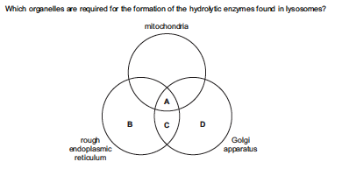

16.
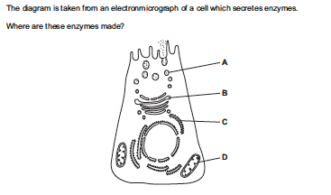

ANSWERS:
1. B
2. C
3. D
4. C
5. C
6. D
7. B
8. D
9. C
10. C
11. C
12. D
13. C
14. C
15. D
16. C

