1. Draw plan diagrams of the different leukocytes below:

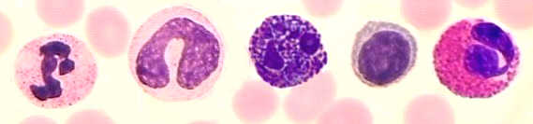

***Leukocytes***

1. (a) Draw plan diagrams of three blood cells:

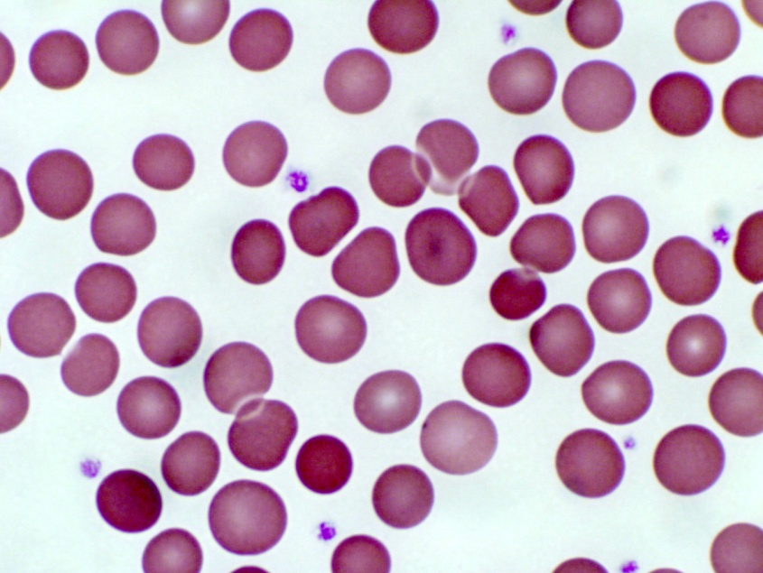

(b) Label the platelets using arrows.

1. The diagram shows blood as seen under a microscope.



Which identifies parts P, Q, R and S of the blood?

1. The diagram shows some parts from the blood of a mammal.



Which part would contain the breakdown products of bacterial cells? _____, __________________

1. Capillary network: Draw arrows to show direction of blood flow, formation of tissue fluid and lymph and movement of substance. Use a key/colours for different arrow styles.

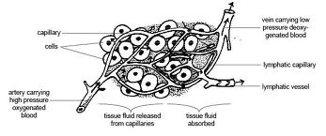

Key:

1. Match the number with the structure in the capillary network

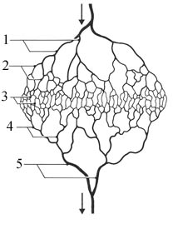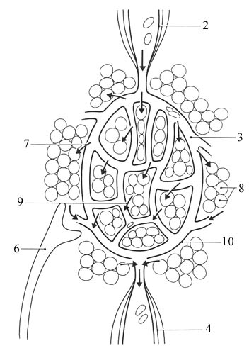

***Capillary Bed Schematised diagram of capillary network.***

­_______Lymph capillary

_______Capillary fluid entering tissues

_______Tissue cells bathed in fluid

_______Tissue fluid entering capillaries

_______Endothelial cell layer

_______Arteries

_______Arterioles

_______Capillaries

_______Venules

­_______Veins

1. Construct a comparative table of differences between blood, tissue fluid and lymph.

|  |  |
| --- | --- |
|  |  |
|  |  |
|  |  |

1. Write an explanation of how tissue fluid and lymph are formed from blood and outline their functions.