1. Is the cell in ***Figure 1.1*** to the right an animal or plant cell? ___________

How do you know? List two observations.

(a)____________________________________

(b)____________________________________

***You will need a ruler and a calculator

# 

1. Match the cell part with the correct letter from ***Figure 1.1***.

______ Cell membrane ______ Centrioles

______ Chromatin ______ Cytoplasm

______ Golgi ______ Lysosome

______ Mitochondria ______ Nuclear envelope

______ Nucleolus ______ Ribosomes

______ Rough ER ______ Smooth ER

***Figure 1.1***

1. Match the structure with the correct letter from the diagram below.

______ Bound ribosomes ______ Cell membrane

______ Cell wall ______ Central vacuole

______ Chloroplast ______ Cytoplasm

______ Golgi ______ Mitochondria

______ Nuclear envelope ______ Nuclear Pore

______ Nucleolus ______ Rough ER

***Figure 1.2***



1. Is the cell pictured in number 8 above an animal or plant cell? _______________

How do you know? List two observations.

(a)___________________________________

(b)___________________________________

1. This TEM shows part of a mammalian liver cell, magnified ×11 000.

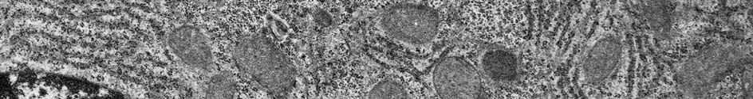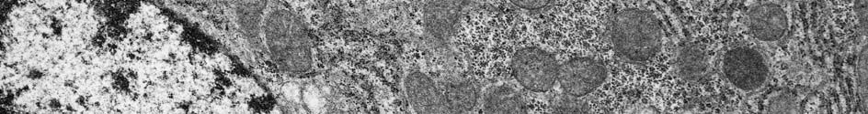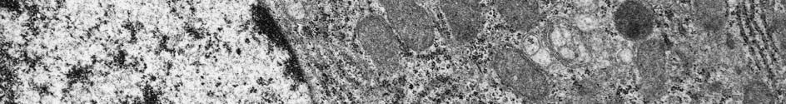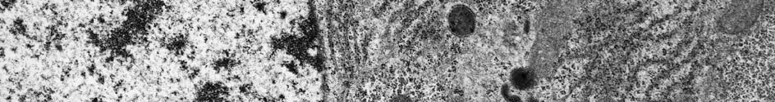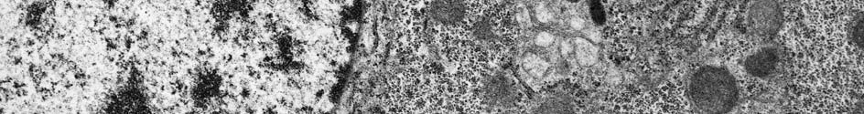

**A**

**B**

**C**

**D**

Identify the labelled structures and write a brief statement of their functions in the table below.

|  |  |  |
| --- | --- | --- |
| **Label** | **Name of structure** | **Function** |
| **A** |  |  |
| **B** |  |  |
| **C** |  |  |
| **D** |  |  |

[2]

[2]

[2]

[2]

1. This cell contains large numbers of the structure labelled C. Explain why. [2]

……………………………………………………………………………………

……………………………………………………………………………………

……………………………………………………………………………………

1. Measure the length of the structure labelled C on the image. Use the magnification to

calculate its real length. Show your working. [2]

Total: [12]

1. Which type of membrane would be present in the largest quantity in a prokaryotic cell?
   1. cell surface membrane
   2. mitochondrial cristae
   3. nuclear envelope
   4. smooth endoplasmic reticulum
2. Which type of cell would contain the greatest relative numbers of mitochondria?
   1. bacterial cell
   2. mesophyll cell
   3. muscle cell
   4. parenchyma cell
3. In a cell that is specialised for secreting protein, which of the following would be present in relatively large amounts?
   1. cell surface membrane
   2. Golgi vesicles
   3. lysosomes
   4. smooth endoplasmic reticulum
4. Which structure could be described as a microtubule-organising centre?
   1. centriole
   2. Golgi apparatus
   3. Nucleus
   4. Spindle
5. What are microtubules made of?
   1. cellulose
   2. DNA
   3. lipid
   4. protein
6. Which structure could be found in a plant cell but **not** in a prokaryotic cell?
   1. 20 nm ribosomes
   2. cell surface membrane
   3. circular DNA
   4. thylakoid
7. Which organelle makes lysosomes?
   1. Golgi apparatus
   2. nucleus
   3. ribosome
   4. smooth endoplasmic reticulum
8. A protein that is to be secreted from a cell would pass through a sequence of cell organelles in the following order:
   1. Golgi apparatus → rough endoplasmic reticulum → secretory vesicle
   2. Golgi apparatus → secretory vesicle → rough endoplasmic reticulum
   3. rough endoplasmic reticulum → Golgi apparatus → secretory vesicle
   4. secretory vesicle → Golgi apparatus → rough endoplasmic reticulum
9. What explains the fact that an increase in the voltage used in a transmission electron microscope results in an increase in the resolution obtained?
   1. The electromagnetic lenses function more efficiently.
   2. Increasing the voltage increases the magnification.
   3. The electron beam can penetrate the specimen more easily.
   4. The wavelength of the electrons is shortened.
10. The results of testing a solution for the presence of three biological molecules are shown in the table.

Which biological molecules are present in the solution?

|  |  |
| --- | --- |
| **Test** | **Colour of solution after test** |
| iodine in potassium iodide solution | orange |
| Benedict’s | orange |
| biuret | purple |

* 1. reducing sugar and protein
  2. reducing sugar and starch
  3. protein only
  4. starch only

1. The diagrams show the structure of four monosaccharides.

Which row in the table below identifies **α-glucose** and **β-glucose**?

|  |  |  |
| --- | --- | --- |
|  | α**-glucose** | β**-glucose** |
| **A** | 1 | 3 |
| **B** | 2 | 1 |
| **C** | 3 | 4 |
| **D** | 4 | 2 |

1. Which reaction involves the hydrolysis of glycosidic bonds?
   1. cellulose → glucose
   2. glucose → glycogen
   3. protein → amino acids
   4. triglyceride → fatty acids and glycerol
2. The diagram shows a tripeptide made from three glycine amino acids.

Which of the bonds numbered 1 to 8 represent peptide bonds?

1. 1 and 7
2. 2 and 8
3. 3 and 6
4. 4 and 5
5. The following bonds are among those found in proteins: disulfide, hydrogen, ionic and peptide bonds.

Which row shows the bonds involved in primary, secondary and tertiary protein structures?

|  |  |  |  |
| --- | --- | --- | --- |
|  | **Primary structure** | **Secondary structure** | **Tertiary structure** |
| **A** | disulfide | peptide | hydrogen |
| **B** | peptide | hydrogen | ionic |
| **C** | peptide | ionic | hydrogen |
| **D** | hydrogen | peptide | ionic |

1. Which of the following describes a molecule of haemoglobin?
   1. a central haem group enclosed by four coiled globin polypeptides
   2. a central globin group enclosed by four coiled haem polypeptides
   3. four coiled globin polypeptides, each with a central haem group
   4. four coiled haem polypeptides, each with a central globin group
2. Which statement about the properties of water is not correct?
3. Evaporation of water is an effective means of cooling an organism.
4. Large volumes of water are slow to change temperature as the environmental temperature changes.
5. The solid form of water, ice, is more dense than the liquid form.
6. Water is an excellent solvent for ions and polar molecules.
7. Amylopectin is formed from amylose by a plant cell detaching short lengths of an amylose chain and reattaching them as branches.

Which bonds are broken and which are formed when amylose is converted into amylopectin?

|  |  |  |
| --- | --- | --- |
|  | **Bonds broken** | **Bonds formed** |
| **A** | α 1,6 | β 1,4 |
| **B** | α 1,4 | α 1,6 |
| **C** | β 1,4 | α 1,4 |
| **D** | β 1,6 | β 1,6 |

21. The graph shows the variation in melting point of triglycerides with different numbers of carbon atoms in their fatty acid chains.



What explains these results?

* 1. Triglycerides with longer fatty acid chains have stronger intermolecular forces and so have a lower melting point.
  2. Triglycerides with longer fatty acid chains have weaker intermolecular forces and so have a higher melting point.
  3. Triglycerides with shorter fatty acid chains have stronger intermolecular forces and so have a higher melting point.
  4. Triglycerides with shorter fatty acid chains have weaker intermolecular forces and so have a lower melting point.

1. In spider silk, the polypeptide chains have the amino acid sequence Gly-Ala-Gly-Ala repeated many times, and the chains pack together as shown in the diagram. The diagram shows the R groups of the two amino acids

Which of the following describes this structure?

* + 1. α-helix held together by hydrogen bonds
    2. α-helix held together by ionic bonds
    3. β-sheet held together by hydrogen bonds
    4. β-sheet held together by ionic bonds