AICE Biology Practice Questions:
Transport in Multicellular Plants

Paper 1: Multiple Choice.

- The movement of water through xylem vessels is affected by external factors.
A decrease in which external factor would result in an increase in water movement?
    - atmospheric humidity
    - external temperature
    - light intensity
    - wind velocity

- The diagram shows the water potential () in some plant cells and in their environment.
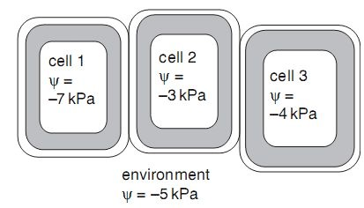
Which statement describes the movement of water between these cells and between them and their environment?
    - All three cells are turgid, so no water moves.
    - Water moves from cell 1, cell 3 and the environment into cell 2.
    - Water moves from cell 3 to the environment, and from the environment to cell 1.
    - Water moves from the environment into cells 1, 2 and 3.

- Why is the mass flow of sap through sieve elements described as an active process? A Phloem sap is able to flow in sieve elements against the pull of gravity.
    - Sucrose is loaded into a sieve element against a concentration gradient.
    - Sucrose passes out of the phloem into regions where cells are dividing.
    - Water follows sucrose into a sieve element down a water potential gradient.

- What is the main function of a companion cell in mature phloem tissue?
    - providing cytoplasmic contact with the sieve tube for loading
    - providing structural support for the sieve tube element
    - providing the nucleus for cell division in the phloem
    - providing the source of assimilates for storage

- In constructing a plan diagram of a transverse section of a dicotyledonous leaf, which feature should not be included?
  - chloroplasts in the palisade mesophyll layer
  - cuticle on the upper epidermis
  - vascular bundles in the leaf lamina
  - xylem in the vascular bundles

- The diagram shows a model which can be used to demonstrate mass flow.
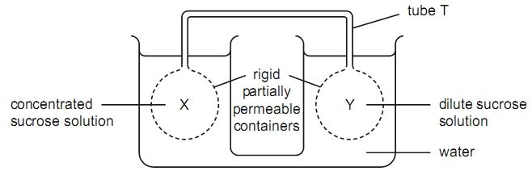
X and Y are filled with sucrose solutions of different concentration, causing water to move in or out of X and Y by osmosis or as a result of hydrostatic pressure. Sucrose solution then moves through the tube T joining X and Y. Which description of this is correct?

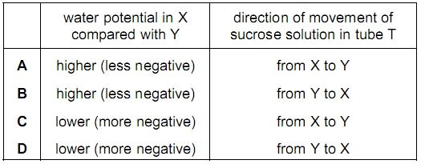

- The graph shows the relationship between the loss of water vapour through stomata and an environmental factor.
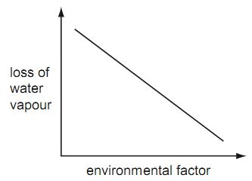

What is the environmental factor?
A air temperature
  - atmospheric humidity
  - light intensity
  - wind velocity

- The diagram shows a longitudinal section through transport tissue in a plant stem.
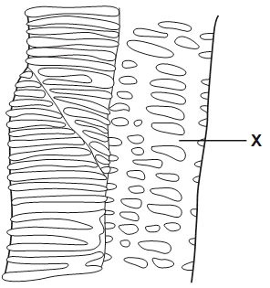
What are the names of the structure labelled X and the tissue in which it is found?

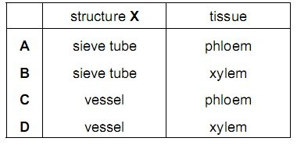

9. What is responsible for the movement of water up xylem vessels in plants?
- active loading of water against the water potential gradient in the roots and osmosis in the vessels
- increasing water potential at the top of xylem vessels, and osmosis in the roots
- decreasing water potential at the top of the xylem vessels, with cohesion of water in the vessels

D translocation in the leaves, with capillarity in the xylem vessels

- What occurs in the apoplast and symplast pathways?

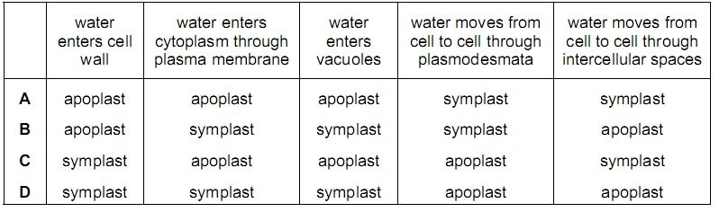
[S07 23]

- The diagrams show transverse sections of parts of a plant.
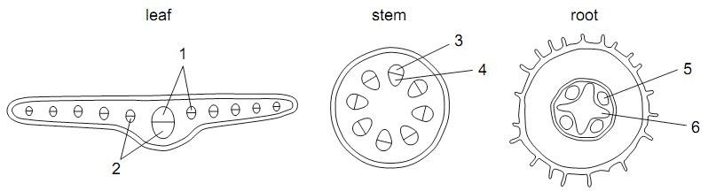

In the cross sections, what do 1, 2, 3, 4, 5 and 6 represent?

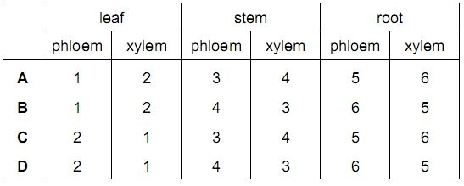

12. Land flooded by the sea is not suitable for growing plants long after the salty flood water has drained away. The diagram represents a transverse section through a part of the root of a plant.

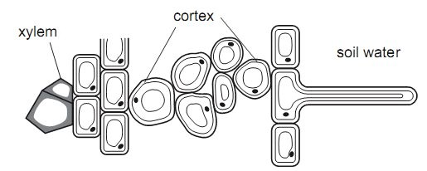
Which values of water potential (kPa) in the xylem and soil water help to explain why the land flooded with salty water is unsuitable for growth of plants?

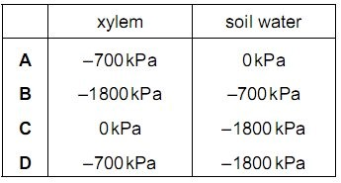

Paper 2: Structured Questions
1. Fig. 4.1 shows transverse sections of a root and a stem.
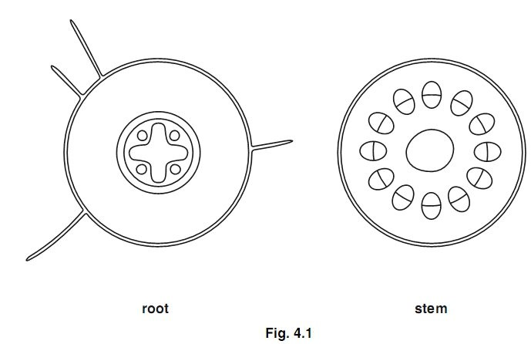
- (i) Shade in an area in the transverse section of the root where there are cells specialised for the transport of water. [1]
(ii) Shade in an area in the transverse section of the stem where there are cells specialised for the transport of sucrose. [1]

- Suggest why the vascular bundles in the stem are situated towards the outside.
_____________________________________________________________________________________
___________________________________________________________________________________[1]
- Describe the process by which water passes from the soil into the root hairs.
_____________________________________________________________________________________
_____________________________________________________________________________________
_____________________________________________________________________________________
___________________________________________________________________________________[2]
- Explain how water passes from the stem to the air surrounding a leaf.
_____________________________________________________________________________________
_____________________________________________________________________________________
_____________________________________________________________________________________
_____________________________________________________________________________________
_____________________________________________________________________________________ ___________________________________________________________________________________[4]
[Total : 9]

2. Fig. 3.1 shows a potometer that is used for measuring rates of water uptake by leafy shoots.
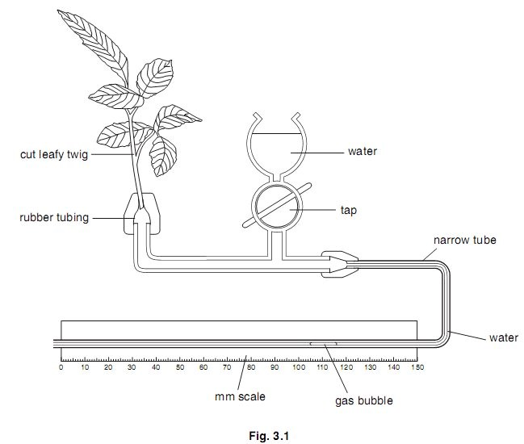

A student used the potometer shown in Fig. 3.1 to investigate the rate of water uptake of a leafy shoot under six different sets of conditions. The student changed two environmental conditions around the plant: • temperature
• wind speed.

For each experiment, the apparatus was left in the conditions until the rate of water uptake by the leafy shoot became constant. The student took several measurements during each experiment and calculated the mean rate of movement of the gas bubble. The results are recorded in Table 3.1.
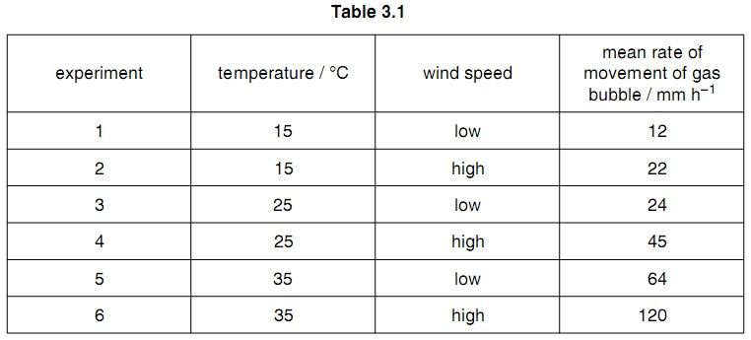
(b) Using the data in Table 3.1, describe and explain the effect of the two conditions that the student changed during the investigation on the rate of water uptake.

temperature ___________________________________________________________________________
_____________________________________________________________________________________
_____________________________________________________________________________________
_____________________________________________________________________________________
_____________________________________________________________________________________
_____________________________________________________________________________________ _____________________________________________________________________________________

wind speed ___________________________________________________________________________ _____________________________________________________________________________________
_____________________________________________________________________________________
_____________________________________________________________________________________
_____________________________________________________________________________________
_____________________________________________________________________________________
___________________________________________________________________________________[4]

The rate of water movement up the leafy shoot was measured before it was cut from the plant. The rate was found to be less than the rate of water uptake from the potometer when kept in the same temperature and windspeed conditions.

(c) Suggest why the rate of water movement in an intact shoot is less than that measured in the potometer.
_____________________________________________________________________________________
_____________________________________________________________________________________ ___________________________________________________________________________________[2]
[Total: 11]

3. Fig. 2.1 is a drawing of a transverse section of a leaf.
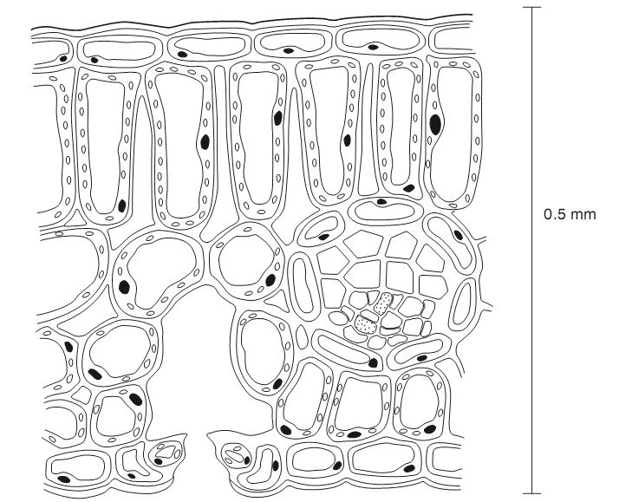
(a) (i) Use label lines and the letters X, S, E and D to indicate the following on Fig.2.1:
X - a xylem vessel
S - a phloem sieve tube
E - a lower epidermal cell

D - a palisade mesophyll cell [4]

(ii) Calculate the magnification of Fig.2.1. Show your working and express your answer to the nearest whole number.

Answer ........................................ [2]
- Name two assimilates that move from the palisade mesophyll cells to the vascular tissue to be exported from the leaf.
  - .......................................................................................................................................
  - ..................................................................................................................................[2]
- Explain, using the term water potential, how water moves from the vascular tissue to the atmosphere.
_____________________________________________________________________________________
_____________________________________________________________________________________
_____________________________________________________________________________________
_____________________________________________________________________________________
_____________________________________________________________________________________
_____________________________________________________________________________________ _________________________________________________________________________________ [4]
[Total: 12]

4. Fig. 2.1 shows part of a summer squash, Cucurbita pepo. Fig. 2.2 is a high power drawing of an area of phloem from a transverse section of the stem of C. pepo.
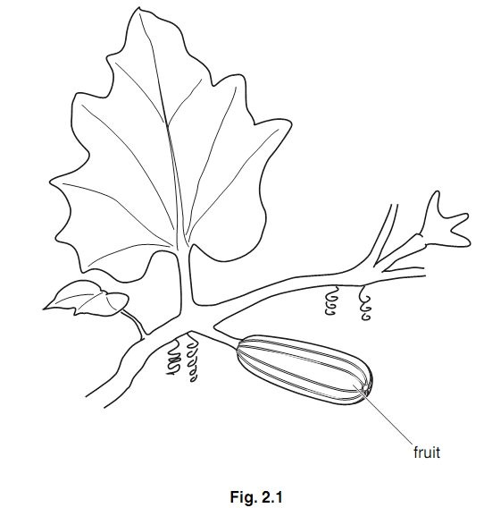
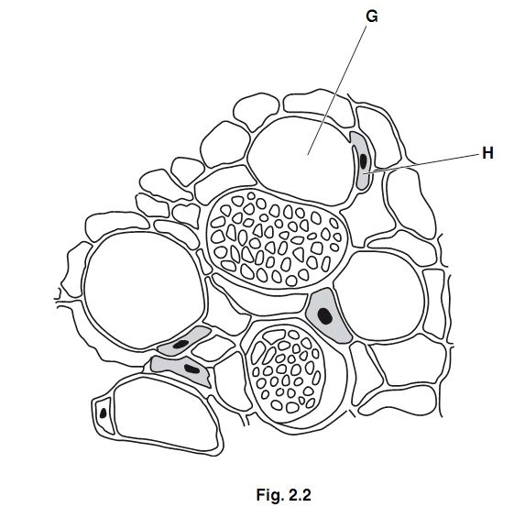
- (i) Name G and H.
  - ..............................................................................................................................
  - ...........................................................................................................................[1]
(ii) Describe three ways in which the structure of a xylem vessel differs from the structure of cell G.
  - ..............................................................................................................................
  - ..............................................................................................................................
  - ..........................................................................................................................[3]
- The liquid extracted from the phloem of C. pepo contains sucrose.
Explain how sucrose is transported in the phloem along the stem from the leaf to the fruit.
_____________________________________________________________________________________
_____________________________________________________________________________________
_____________________________________________________________________________________
_____________________________________________________________________________________
_____________________________________________________________________________________
_____________________________________________________________________________________
_____________________________________________________________________________________
___________________________________________________________________________________[4]

- Most of the sucrose transported in the phloem enters the fruit. Suggest why summer squash fruits are not sweet.
_____________________________________________________________________________________ ___________________________________________________________________________________[1]
[Total: 9] [S06 QP2 2]

